Software Requirements Specification
for

Mini Fahasa Integrated Bookstore Website

, Release 1.0

Version 1.0 approved
Prepared by Group 1
June 29, 2026

Table of Contents
Mini Fahasa Integrated Bookstore Website 1
, Release 1.0 1
Revision History 7
1. Introduction 8
1.1 Purpose 8
1.2 Document Conventions 8
1.3 Project Scope and Product Features 9
1.4 References 9
2. Overall Description 10
2.1 Product Perspective 10
2.2 User Classes and Characteristics 11
2.3 Operating Environment 12
2.4 Design and Implementation Constraints 12
2.5 Assumptions and Dependencies 12
3. System Features 12
3.1 Account & Access Management (FE-1) 12
FR-ACC-01 (UC-05 - Register Account) 12
FR-ACC-02 (UC-06 - Login & UC-09 - Logout) 13
FR-ACC-03 (UC-58 - Manage Customer Accounts & UC-59 - Manage Staff Accounts) 13
FR-ACC-04 (RBAC Authorization) 14
FR-ACC-05 (UC-10 - View/Edit Profile) 14
FR-ACC-06 (UC-11 - View Loyalty Points Balance) 14
3.2 Product Catalog Management (FE-2) 14
FR-PRO-01 (UC-42 - Manage Product) 14
FR-PRO-02 (UC-43 - Manage Categories) 15
FR-PRO-02a (UC-44 - Manage Authors) 15
FR-PRO-02b (UC-45 - Manage Publishers) 15
FR-PRO-02c (UC-46 - Manage Brands) 15
FR-PRO-03 (UC-01 - Browse Catalog, UC-02 - Search Products, UC-03 - View Details, UC-04 - Browse Categories) 16
FR-PRO-04 (UC-52 - View Stock Alerts - BR-06 Auto Clearance) 16
3.3 Shopping Cart & Order Management (FE-3) 16
FR-ORD-01 (UC-07 - View Cart & UC-08 - Update Cart) 16
FR-ORD-02 (UC-12 - Place Order, UC-13 - Apply Discount Codes, UC-14 - Redeem Loyalty Points) 17
FR-ORD-03 (UC-18 - Track Order Status & UC-19 - Cancel Order) 18
FR-ORD-04 (UC-23 - View Order List & UC-25 - Process Order Status) 18
FR-ORD-05 (UC-53 - Manage Holiday Campaign) 18
FR-ORD-06 (UC-16 - View Order History) 19
FR-ORD-07 (UC-17 - View Order Details) 19
FR-ORD-08 (UC-26 - Cancel Order by Sale Staff) 19
FR-ORD-09 (UC-32 - Manage Discount Code) 19
3.4 Inventory Management (FE-4) 20
FR-INV-01 (UC-49 - Adjust Stock & UC-50 - Transfer Stock Between Branches) 20
FR-INV-02 (UC-51 - View Stock Transaction Logs) 20
FR-INV-03 (UC-52 - View Stock Alerts - BR-04 Low Stock Warning) 21
3.5 Payment Processing (FE-5) 21
FR-PAY-01 (UC-15 - Process Payment) 21
FR-PAY-02 (UC-15 - Process Payment - Online VNPay Integration) 21
3.6 Customer Support (FE-6) 22
FR-SUP-01 (UC-20 - Submit Support Request) 22
FR-SUP-02 (UC-22 - Request Return Or Exchange) 22
FR-SUP-03 (UC-33 - View Support Ticket List & UC-35 - Reply to Support Request) 23
FR-SUP-04 (UC-27 - Process Return, UC-28 - Process Exchange, UC-30 - Approve Return/Exchange) 23
FR-SUP-05 (UC-37 - View Support Ticket Statistics) 23
FR-SUP-06 (UC-39 - Initiate Return Or Exchange Request) 23
FR-SUP-07 (UC-40 - View Customer Transaction History) 24
FR-SUP-08 (UC-41 - View Invoices And Order Details) 24
3.7 System Administration (FE-7) 24
FR-ADM-01 (UC-60 - Configure System Parameters) 24
FR-ADM-02 (UC-61 - View System Audit Log) 24
3.8 Reports & Statistics (FE-8) 25
FR-REP-01 (UC-54. View Revenue Report, UC-55. View Stock Report, UC-56. View Order Report, UC-57. View Payment Reconciliation Report) 25
4. Data Requirements 25
4.1 Logical Data Model 25
26
4.2 Data Dictionary 30
Account Table 30
Role Table 31
Category Table 31
Branch Table 31
Product Table 31
Book Table (inherits Product) 32
Stationery Table (inherits Product) 32
Author Table 33
Contributor Table (Book - Author Link) 33
Publisher Table 33
Brand Table 33
Supplier Table 34
Cart Table 34
CartItem Table 34
Voucher (Discount) Table 34
Order Table 35
OrderItem Table 36
PointHistory Table 36
Inventory Table 36
StockLog Table 37
SupportTicket Table 37
SystemParameter Table 38
AuditLog Table 38
4.3 Reports 39
4.3.1 Monthly Revenue & Best-Selling Product Report 39
4.3.2 Inventory Status & Low Stock Report 40
4.3.3 Order Status & Performance Report 40
4.3.4 Payment Reconciliation Report 41
4.3.2 Inventory Status & Low Stock Report 43
4.3.3 Order Status & Performance Report 44
4.3.4 Payment Reconciliation Report 44
4.4 Data Integrity, Retention, and Disposal 45
5. External Interface Requirements 45
5.1 User Interfaces 45
Storefront (Customer Interface): 46
Dashboard (Staff/Manager Interface): 47
5.2 Software Interfaces 48
Google OAuth 2.0 API: 48
VNPay Sandbox API: 49
5.3 Hardware Interfaces 49
5.4 Communications Interfaces 49
6. Quality Attributes 49
6.1 Usability Requirements 49
6.2 Performance Requirements 50
6.3 Security Requirements 50
6.4 Safety Requirements 50
6.5 Availability Requirements 50
6.6 Robustness Requirements 50
Appendix A: Analysis Models 50
1. Use Case Diagram 50
[UseCase] 50
2. Entity Relationship Diagram (ERD) 51
3. Checkout Flow (Activity Diagram) 51
4. State-Transition Diagrams (Lifecycles) 53
4.1 Order Lifecycle 53
4.2 Support Ticket Lifecycle 54

Revision History

Name | Date | Reason For Changes | Version
Le Tien Dung & Tran Huynh Giac | 23/06/2026 | Initialized SRS document framework combining business rules and Use Case list | 1.0 Draft
Le Tien Dung & Tran Huynh Giac | 29/06/2026 | Synchronized all Use Case codes (t.k2qvj9n2h148), integrated Manager role for inventory management, and finalized document based on standard template | 1.0 Final
Le Tien Dung & Tran Huynh Giac | 30/06/2026 | Fixed Use Case mapping errors from 1-61, supplemented missing FRs for CS Staff, Admin, and decomposed requirements for author/publisher/brand management | 1.1 Final

1. Introduction

1.1 Purpose
This Software Requirements Specification (SRS) document details the functional requirements and non-functional requirements for version 1.0 of the Mini Fahasa Integrated Bookstore Website System.
This document is prepared for the following audiences:
- Development Team: Used as a technical basis for designing system architecture, building the database, and implementing software functionalities.
- Testing/QA Team: Used as a foundation for creating test cases.
- Customers & Stakeholders: Used to verify and cross-check the delivery scope, serving as a basis for system acceptance upon completion of Release 1.0.

1.2 Document Conventions
To ensure consistency, readability, and ease of cross-checking, this SRS document applies the following conventions:
1. Requirement Tagging:
  - Functional Requirements: FR-[Module]-[Sequence Number] (Example: FR-ACC-01, FR-ORD-02).
    - ACC (Account): Account management and authorization module.
    - PRO (Product): Product catalog management module.
    - ORD (Cart & Order): Shopping cart and order processing module.
    - INV (Inventory): Inventory management and stock transaction module.
    - PAY (Payment): Payment module.
    - SUP (Support): Customer support and return/exchange module.
    - ADM (Admin): System administration module.
  - Non-functional Requirements: NFR-[Requirement Type]-[Sequence Number] (Example: NFR-SEC-01).
    - SEC (Security): Security.
    - PER (Performance): Performance.
    - USA (Usability): Usability.
    - AVA (Availability): Availability.
2. Business Rules Reference: Codes such as BR-01 to BR-16 refer directly to the project's Business Rules list.
3. Priority Levels:
  - High: Mandatory for core system operation.
  - Medium: Advanced features (e.g., VNPay gateway, applying vouchers).
  - Low: Supplementary features or those to be developed in future releases.

1.3 Project Scope and Product Features
The Mini Fahasa project is an integrated e-commerce storefront and intuitive ERP-Lite inventory management system, operating on two main interfaces:
- Storefront (Online Sales Channel): A minimalist Web interface for Customers to browse, search, and order Books & Stationery in a single order, pay online or via COD, track orders, and submit support/complaint requests.
- Dashboard (Internal Management Panel): An interface for the operational team (Admin, Manager, Sale Staff, CS Staff) to manage inventory, process orders, handle returns/exchanges, and reconcile real-time stock.

Summary of Feature Epics (FE):
- FE-1: Account Management: Registration (age $≥15$), login, Google OAuth 2.0, view/edit personal profile and accumulated points balance.
- FE-2: Product Management: Product management (Book, Stationery), recursive categories, manage authors, publishers, brands, and automated clearance sale alerts.
- FE-3: Cart and Order Management: Cart management, apply birthday discounts/vouchers/loyalty points, place orders, and manage the entire order lifecycle.
- FE-4: Inventory Management: Inventory management for Managers, low stock alerts, and Stock Transaction Logs.
- FE-5: Payment Processing: Process payment method selection, integrate VNPay Sandbox gateway.
- FE-6: Customer Support: Submit support requests (Tickets), CS Staff checks history, invoices, creates return/exchange requests on behalf of customers, and performance statistics.
- FE-7: System Administration: System administration, configure system parameters, and view System Audit Logs.
- FE-8: Reports & Statistics: Export revenue, inventory, order reports, and periodic payment reconciliation for Managers.

1.4 References
1. Vision and Scope Document (Mini Fahasa Project Vision and Scope, Group 1).
2. Business Rules Group 1 (BR-01 to BR-16) (Business Rules, Group 1).
3. Use Cases Group 1 (UC-01 to UC-61) (UseCase).

2. Overall Description

2.1 Product Perspective
Mini Fahasa is a new software system intended to replace traditional sales management methods (using Excel, paper ledgers) by allowing customers to view, order online, and receive home delivery, while simultaneously providing an ERP-Lite management system for the store. The system addresses issues such as: inventory data discrepancies, loss, slow order processing, and the lack of an online sales channel.

The Context Diagram below illustrates the data interaction boundaries between the system and external entities:
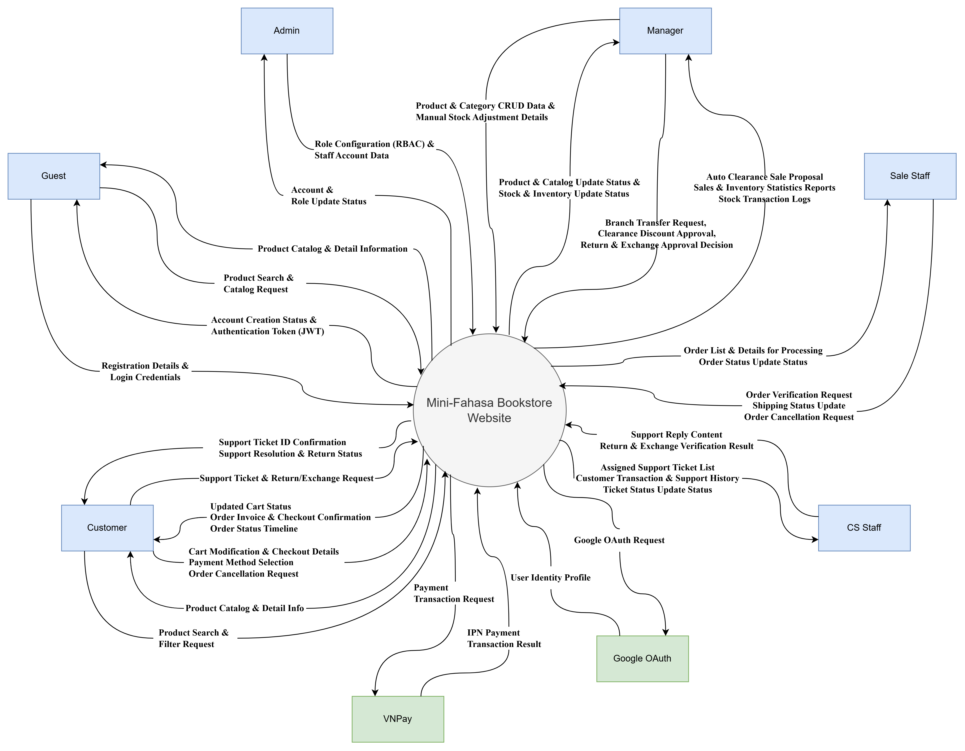
Figure 1. Context diagram for release 1.0 of the Mini Fahasa.

2.2 User Classes and Characteristics
- Guest: Accesses the Storefront to search and browse products but is not logged in.
- Customer: Logged in. Can browse, add products to the cart, place orders, make payments, track orders, and submit support requests.
- Sale Staff: Uses the Dashboard to process orders (PENDING CONFIRMED SHIPPING DELIVERED), update statuses, and check inventory.
- CS Staff (Customer Service Staff): Receives and processes support Tickets, complaints, and return/exchange requests from customers. Has Read-only access to order and customer data.
- Manager: Has full control over the product catalog, inventory (view, manual stock adjustments, inter-branch transfers), promotions, and views revenue and inventory reports.
- Admin: Manages internal user accounts and assigns RBAC roles.

2.3 Operating Environment
- Client (Frontend): Modern web browsers (Chrome, Firefox, Safari, Edge) supporting HTML5/CSS3. Compatible and displays well on Desktop, Tablet, and Smartphone.
- Server (Backend): Server running Linux/Windows operating system. Java Runtime Environment (JRE 17+).
- Database: MySQL or PostgreSQL.

2.4 Design and Implementation Constraints
- CO-1: The Backend system uses Java Spring Boot, Frontend uses ReactJS / pure HTML CSS JS.
- CO-2: Transactions related to inventory and payments must adhere to ACID properties to ensure data integrity (Data discrepancies are not allowed).
- CO-3: Sensitive configuration information (JWT Secret, API Keys) must not be stored directly in the source code (Hard-code).

2.5 Assumptions and Dependencies
- AS-1: The production deployment server is capable of handling at least 100 concurrent users.
- AS-2: The VNPay Sandbox environment operates stably throughout the development and testing process.
- DE-1: The Single Sign-On (SSO) feature depends on the Google OAuth 2.0 API.
- DE-2: Online payment depends on the VNPay system.

3. System Features

3.1 Account & Access Management (FE-1)
Description: Provides functionality for users to register, log in, manage personal profiles, and system authorization.
Functional Requirements:

FR-ACC-01 (UC-05 - Register Account)
- Input: Full Name, Email, Phone Number, Password, Confirm Password, Date of Birth (format YYYY-MM-DD).
- Validation Rules:
  - Email must be in RFC 5322 format (regex: ^[a-zA-Z0-9._%+-]+@[a-zA-Z0-9.-]+\.[a-zA-Z]{2,}$) and not exist in the system.
  - Phone number: 10 digits, starting with 0 (regex: ^0[0-9]{9}$).
  - Password: Minimum 8 characters, containing at least 1 uppercase letter, 1 lowercase letter, and 1 number.
  - Date of Birth: System calculates age = (Current Date − Date of Birth) / 365.25. Must be $≥15$ years old.
- Output (Happy Path): Account created successfully, confirmation email sent (if applicable), redirects to the Login page.
- Error Codes:
  - ERR-ACC-01: "Email is already in use by another account."
  - ERR-ACC-02: "Invalid phone number format (10 digits, starting with 0)."
  - ERR-ACC-03: "Password must be at least 8 characters long, including uppercase, lowercase, and numeric characters."
  - ERR-ACC-04: "You must be at least 15 years old to register an account."
  - ERR-ACC-05: "Password confirmation does not match."

FR-ACC-02 (UC-06 - Login & UC-09 - Logout)
- Input: Email, Password.
- Output (Happy Path): System authenticates successfully, issues JWT Access Token (30-minute validity) and Refresh Token (7-day validity). Redirects: Customer Storefront; Sale/CS/Manager/Admin Dashboard.
- Error Codes:
  - ERR-ACC-06: "Incorrect email or password."
  - ERR-ACC-07: "Your account has been disabled. Please contact Admin."
- Exception Flow: If the JWT Access Token expires, the Client automatically sends the Refresh Token to obtain a new Access Token. If the Refresh Token also expires, redirects to the Login page.

FR-ACC-03 (UC-58 - Manage Customer Accounts & UC-59 - Manage Staff Accounts)
- Scope: Only Admin has permission to execute.
- Functionality: Admin can manage the Customer list (UC-58) and internal staff accounts (UC-59).
- Customer Management Details (UC-58): View customer list, lock/unlock customer accounts for policy violations, manually adjust loyalty points (in case of transaction issues).
- Staff Management Details (UC-59): Create new staff accounts (Sale Staff, CS Staff, Manager), assign roles (Role), deactivate staff accounts, or reset staff passwords.
- Constraints: Admin cannot deactivate their own currently logged-in account.
- Error Codes:
  - ERR-ACC-08: "Cannot deactivate the currently logged-in Admin account."

FR-ACC-04 (RBAC Authorization)
- The system implements strict authorization based on the JWT role (Admin, Manager, Sale, CS, Customer) configured when the Admin manages staff accounts (UC-59).
- Every API endpoint must verify the JWT token and role before executing business logic.
- Permission Matrix:

FR-ACC-05 (UC-10 - View/Edit Profile)
- Scope: For logged-in Customers.
- Functionality: Customers can view and edit their own personal information.
- Input: Full Name, Phone Number, Default Shipping Address, Date of Birth.
- Constraints: When updating to a new date of birth, the $≥15$ years old minimum age requirement must still be met. The phone number must be in the correct 10-digit format.
- Output: Information updated successfully, saved to the database, and status response sent to the Client.
- Error Codes:
  - ERR-ACC-09: "Invalid update information (age < 15 or incorrect phone format)."

FR-ACC-06 (UC-11 - View Loyalty Points Balance)
- Scope: For logged-in Customers.
- Functionality: Customers view their current loyalty points balance and points transaction history.
- Output: Returns the current points and a list of points history (transaction date, related order code, points added/deducted, reason for change).

3.2 Product Catalog Management (FE-2)
Description: Manages products including Books and Stationery, categories, and related entities.
Functional Requirements:

FR-PRO-01 (UC-42 - Manage Product)
- Scope: Only Manager has permission to execute.
- Functionality: Create, Update, Soft Delete items.
- Input when creating Book: Title, Price (DECIMAL, $>0$), Product Images (max 5 images, each $≤5MB$, JPG/PNG format), Category (Category ID), Author (Author ID), Publisher (Publisher ID), ISBN, Pages (number of pages), Description.
- Input when creating Stationery: Title, Price, Product Images, Category, Brand (Brand ID), Color, Material, Origin (country of origin).
- Validation Rules:
  - Price must be $>0$ VND.
  - Title must not be duplicated within the same Category.
- Error Codes:
  - ERR-PRO-01: "Product title already exists in this category."
  - ERR-PRO-02: "Price must be greater than 0."
  - ERR-PRO-03: "Image exceeds allowed size (max 5MB/image)."

FR-PRO-02 (UC-43 - Manage Categories)
- Managers can manage a multi-level recursive Category structure (Parent Category Child Category).
- Constraints: Cannot delete a Category if there are still products linked to it.
- Error Codes:
  - ERR-PRO-04: "Cannot delete category because there are still products belonging to this category."

FR-PRO-02a (UC-44 - Manage Authors)
- Functionality: Managers perform CRUD operations on book author information.
- Input: Author name, brief biography, birth/death year.
- Constraints: Cannot delete an author if there are linked books in the system.

FR-PRO-02b (UC-45 - Manage Publishers)
- Functionality: Managers perform CRUD operations on book publisher information.
- Input: Publisher name, address, contact phone number, tax code.
- Constraints: Cannot delete a publisher if there are linked books in the system.

FR-PRO-02c (UC-46 - Manage Brands)
- Functionality: Managers perform CRUD operations on stationery brand information.
- Input: Brand name, country of origin, logo.
- Constraints: Cannot delete a brand if there are linked stationery products.

FR-PRO-03 (UC-01 - Browse Catalog, UC-02 - Search Products, UC-03 - View Details, UC-04 - Browse Categories)
- Displays the product list with pagination (default 20 products/page).
- Automatic Badging:
  - "Low Stock": When StockQuantity $< 10% \times$ Quantity_of_Last_Import (BR-04).
  - "Best Seller": When a product sells $>50$ units/month (BR-13), categorized into 3 price segments (BR-05): Under 500k | 500kâ€“1M | Over 1M.
- Filters: By Category (UC-04), Price Range (Minâ€“Max), Author/Brand, Sorting (Price Asc/Desc, Newest, Best Selling).
- Applicable Rules: BR-04, BR-05, BR-13.

FR-PRO-04 (UC-52 - View Stock Alerts - BR-06 Auto Clearance)
- The system runs a Background Job (Cronjob) at 00:00 every day to scan all products.
- Trigger Condition: Product price  VND AND actual inventory holding time $>1.5×$ expected sell-out time.
- Behavior: The system automatically creates a proposal for a clearance sale discount program and displays an alert (Stock Alert) to the Manager on the Dashboard.
- Note: The Manager must manually approve (Approve) before the discount program is applied. The system does NOT automatically change prices.
- Applicable Rules: BR-06.

3.3 Shopping Cart & Order Management (FE-3)
Description: The process from cart management, applying discounts, checkout to handling the order lifecycle.
Functional Requirements:

FR-ORD-01 (UC-07 - View Cart & UC-08 - Update Cart)
- Customers can view the cart (UC-07) and update the cart (UC-08 - add new products to the cart, increase/decrease product quantity, or remove products from the cart).
- Inventory Mechanism: Inventory is NOT deducted when a product is in the cart. Inventory is only deducted upon a successful Checkout. If inventory $=0$ at the time of Checkout, the system returns an error.
- Validation Rules:
  - Quantity added to cart must be $≥1$.
  - The system displays a warning if the quantity in the cart $>$ current stock quantity (but still allows keeping it in the cart).
- Error Codes:
  - ERR-ORD-01: "This product is currently out of stock."

FR-ORD-02 (UC-12 - Place Order, UC-13 - Apply Discount Codes, UC-14 - Redeem Loyalty Points)
The Checkout flow is decomposed into sequential steps:
- FR-CHK-01 (Inventory Verification): The system locks and re-verifies inventory for each product in the cart at the moment "Checkout" is clicked. If any product is out of stock, the entire Checkout is blocked, and a list of insufficient products is displayed.
  - ERR-CHK-01: "Product [Product Name] only has [X] units left, you selected [Y] units."
- FR-CHK-02 (Discount Calculation): The system applies discounts in the following priority order:
  - Step 1: Check birthday If today is the Customer's birthday AND this is the first order of the day 10% discount on the total order (BR-09).
  - Step 2: If the Customer does NOT use the birthday discount Allow entering up to 3 Voucher codes (UC-13). Calculation logic: Additive discount percentages on the original price. If the total discount exceeds 10% of the order value (BR-14), the system automatically caps the discount at exactly 10%.
  - Step 3: If the Customer does NOT use the birthday discount AND does NOT use Vouchers Allow Redeeming Loyalty Points (UC-14, $≥5000$ points, conversion rate 100 points = 1,000 VND, max 10% discount on the order) (BR-11). If the calculated point discount exceeds 10%, the system automatically caps it at exactly 10%.
  - Exclusion Rule: Birthday Discount, Vouchers, and Points Redemption are mutually exclusive — only 1 of the 3 can be selected (BR-14).
  - ERR-CHK-02: "Cannot use discount codes and birthday discount simultaneously."
  - ERR-CHK-04: "You need a minimum of 5,000 points to redeem a voucher. Current points: [X]."
- FR-CHK-03 (Order Creation): After calculation is complete, the system executes within 1 Database Transaction (ACID):
  - Deduct StockQuantity for each OrderItem.
  - Create Order record (status = PENDING) and OrderItem.
  - Add loyalty points: Points += floor(TotalPrice / 1000) (BR-10).
  - Write StockLog (type = ORDER_DEDUCT).
  - If any step fails Rollback the entire Transaction.
  - ERR-CHK-05: "An error occurred while processing the order. Please try again."
- Applicable Rules: BR-09, BR-10, BR-11, BR-14.

FR-ORD-03 (UC-18 - Track Order Status & UC-19 - Cancel Order)
- Customers track order status on the Storefront (displays status timeline) (UC-18).
- Customers are only allowed to cancel an order when the status is PENDING (UC-19).
- Upon cancellation: The system refunds inventory (StockLog type = ORDER_RETURN), refunds deducted points, and refunds money if paid via VNPay.
- Error Codes:
  - ERR-ORD-02: "Cannot cancel an order that has been confirmed or is being shipped."

FR-ORD-04 (UC-23 - View Order List & UC-25 - Process Order Status)
- Sale Staff on the Dashboard manages orders: View order list (UC-23), view order details (UC-24), and transition order statuses (UC-25) following the sequential process:
  - PENDING CONFIRMED (Confirm order after verifying physical inventory).
  - CONFIRMED SHIPPING (Handed over to the shipping provider).
  - SHIPPING DELIVERED (Customer receives goods successfully).
- Constraints: Statuses must only be transitioned sequentially. Skipping steps is not allowed (e.g., PENDING SHIPPING is invalid).
- Error Codes:
  - ERR-ORD-03: "Cannot transition status from [Status A] to [Status B]."

FR-ORD-05 (UC-53 - Manage Holiday Campaign)
- Scope: Only Manager has permission to execute.
- Functionality: Create and manage promotional campaigns during National Holidays (BR-15).
- Input when creating a campaign: Promotion campaign name, Start Date (format YYYY-MM-DD HH:mm), End Date, List of Products/Categories applicable to the program, Discount Percentage.
- Constraints:
  - Products with original price  VND: configurable for 10â€“15% discount.
  - Products with original price $≥1,000,000$ VND: configurable for 5â€“10% discount.
  - National Holiday promotions CANNOT be stacked with Vouchers or points redemption.
- Applicable Rules: BR-15.

FR-ORD-06 (UC-16 - View Order History)
- Scope: For logged-in Customers.
- Functionality: View the list of all orders the customer has ever placed.
- Output: Returns a paginated list of orders. Each order includes: Order ID, Order Date, Total Payment Amount, Payment Method, and Current Status.

FR-ORD-07 (UC-17 - View Order Details)
- Scope: For logged-in Customers.
- Functionality: View details of a specific order.
- Output: Returns information: Order ID, Name and quantity of each product in the order, Unit price at the time of purchase, Total original price, Total discount amount, Final total payment amount, Shipping Address, Payment Information, and Order Status History Tracker (Timeline).

FR-ORD-08 (UC-26 - Cancel Order by Sale Staff)
- Scope: For Sale Staff and Managers on the Dashboard.
- Functionality: Cancel a customer's order when delivery fails or upon a valid cancellation request from the customer.
- Constraints: Can only be cancelled when the order is in PENDING or CONFIRMED status.
- System Behavior:
1. Transition order status to CANCELLED.
2. Automatically refund the corresponding inventory quantities of the items in the order back to the physical warehouse.
3. Write StockLog (type = ORDER_RETURN).
4. Refund the loyalty points the customer used (if any) and revoke the points awarded for the purchase.

FR-ORD-09 (UC-32 - Manage Discount Code)
- Scope: For Sale Staff and Managers on the Dashboard.
- Functionality: Create new, edit, view list, and deactivate discount codes (Vouchers) on the system.
- Input when creating Voucher: Voucher code (uppercase alphanumeric string, e.g., FAHASA20), Discount Type (Percentage or Fixed Amount), Discount Value, Expiry Date, Minimum order value to apply, Maximum usage limit, Maximum discount amount.
- Validation Rules:
  - Discount value must be $>0$.
  - Voucher code must not duplicate any active codes.
  - Expiry time must be greater than the current date.
- Output: Voucher code is successfully saved and displayed in ACTIVE status on the system.

3.4 Inventory Management (FE-4)
Description: Track and control the actual flow of goods to prevent loss and inventory discrepancies.
Functional Requirements:

FR-INV-01 (UC-49 - Adjust Stock & UC-50 - Transfer Stock Between Branches)
- Scope: Only Manager has permission to execute (UC-47 to view inventory).
- Functionality: Manually adjust inventory up/down (UC-49), transfer goods between branches (UC-50, BR-07), view inventory reports (UC-55).
- Validation Rules:
  - First-time new import (UC-48): Maximum 100 units/branch. Exception: Textbooks (SGK) maximum 500 units/branch (BR-01).
  - Formula for calculating supplementary import quantity: $Q=R×T$ (BR-02), where R = Average sales velocity (units sold per day/month since first import), T = Target sell-out period (expected number of days to sell out the stock).
  - Not allowed to reduce inventory below 0.
- Error Codes:
  - ERR-INV-01: "First-time import quantity exceeds the allowed limit (100 units, Textbooks: 500 units)." (BR-01)
  - ERR-INV-02: "Cannot reduce inventory below 0."
- Applicable Rules: BR-01, BR-02, BR-07.

FR-INV-02 (UC-51 - View Stock Transaction Logs)
- Every inventory change must be logged (Audit Trail) in the StockLog table.
- Transaction Types: IMPORT (Stock entry), EXPORT (Stock exit/Transfer), ORDER_DEDUCT (Deduction due to order), ORDER_RETURN (Refund due to order cancellation/return), DEFECTIVE_RETURN (Defective goods return).
- Logged Information: Product Code, Transaction Type, Quantity Change (+/-), Performer (Account ID), Time (Timestamp), Notes (Reason).

FR-INV-03 (UC-52 - View Stock Alerts - BR-04 Low Stock Warning)
- Scope: For Managers on the Dashboard.
- Functionality: Display a list of low stock alerts so the Manager can promptly create a supplementary import order.
- Trigger Condition: When StockQuantity < 10% * Quantity_of_Last_Import for the current branch (BR-04).
- System Behavior: Automatically creates a red alert (Alert) next to the item on the inventory management page of the Dashboard. Sends a periodic warning email to the Manager at the end of the day if the alert list has not been processed.
- Applicable Rules: BR-04.

3.5 Payment Processing (FE-5)
Description: Integrate and process payments for orders.
Functional Requirements:

FR-PAY-01 (UC-15 - Process Payment)
- The system allows Customers to select a payment method during the checkout flow.
- Options:
  - COD (Cash on Delivery): Order is created with PENDING status, pay upon receipt.
  - VNPay: Redirects to the VNPay Sandbox payment gateway for online payment.

FR-PAY-02 (UC-15 - Process Payment - Online VNPay Integration)
- Main Flow:
1. System generates a VNPay payment URL with SHA256/HMAC signature.
2. Redirect Customer to the VNPay Sandbox payment page.
3. After payment, VNPay sends an IPN (Instant Payment Notification) callback to the Backend.
4. Backend verifies the IPN signature and updates the payment status.
- Retry Mechanism: If calling the VNPay API times out ($>10$ seconds), the system retries a maximum of 3 times, with a 2-second interval between each try.
- Exception Flow:
1. If the Customer closes the browser midway Order remains in PENDING status. The system waits for the IPN callback from VNPay for 15 minutes. If the time expires without receiving a callback Automatically cancel the order and refund inventory.
2. If all 3 Retries fail Display error message, keep order in PENDING status, allow Customer to re-select payment method or switch to COD.
- Error Codes:
  - ERR-PAY-01: "VNPay payment failed. Please try again or choose COD."
  - ERR-PAY-02: "Payment session expired. Please perform the transaction again."

3.6 Customer Support (FE-6)
Description: Process support requests, complaints, and returns/exchanges.
Functional Requirements:

FR-SUP-01 (UC-20 - Submit Support Request)
- Customer creates a support request Ticket on the Storefront.
- Input: Subject, Description content, Related Order ID (optional), Attached images (max 3 images, each $≤5MB$, JPG/PNG).
- Output: Ticket is created with OPEN status, displaying the Ticket ID for the Customer to track (UC-21 - View Support Request Status).

FR-SUP-02 (UC-22 - Request Return Or Exchange)
- Pre-conditions:
1. Order must be in DELIVERED status.
2. Timeframe: Within 7 calendar days (including Saturdays, Sundays, and holidays) from the successful delivery date (BR-12).
- Mandatory Input:
1. Order ID.
2. Reason for return/exchange (select from list + optional notes).
3. Photo of the invoice (mandatory, max 3 images, each $≤5MB$, JPG/PNG).
4. Photo of the goods with intact stamps/tags (mandatory, max 3 images, each $≤5MB$, JPG/PNG).
- Processing Flow: CS Staff verifies documentary evidence images If valid, create a return/exchange request pending Sale Staff or Manager approval.
- Error Codes:
  - ERR-SUP-01: "The 7-day limit from the delivery date has passed. Cannot create a return/exchange request."
  - ERR-SUP-02: "Please upload a photo of the invoice for verification."
  - ERR-SUP-03: "Please upload a photo of the goods with intact stamps/tags."
  - ERR-SUP-04: "Image exceeds allowed size (max 5MB/image, JPG/PNG format)."
- Applicable Rules: BR-12.

FR-SUP-03 (UC-33 - View Support Ticket List & UC-35 - Reply to Support Request)
- CS Staff receives Ticket (UC-34 to view details), responds, and closes Ticket.
- SLA (Service Level Agreement): All Tickets must be fully resolved within 2 working days from creation (BR-08, UC-36).
- Alert System: If a Ticket is overdue by 2 days without being resolved, the system automatically sends an alert (Notification) to the CS Staff and Manager on the Dashboard.
- Error Codes:
  - ERR-SUP-05: "Ticket is already closed, cannot be edited."
- Applicable Rules: BR-08.

FR-SUP-04 (UC-27 - Process Return, UC-28 - Process Exchange, UC-30 - Approve Return/Exchange)
- CS Staff verifies return/exchange documents (UC-38). If conditions of BR-12 are met, create a return/exchange order awaiting approval.
- Manager or Sale Staff approves (UC-30 or UC-31 to reject) on the Dashboard.
- After successful approval:
  - Return Flow: Update inventory (add back to product stock), create StockLog ORDER_RETURN.
  - Exchange Flow: Deduct inventory for replacement product, create StockLog ORDER_DEDUCT and add exchange note.

FR-SUP-05 (UC-37 - View Support Ticket Statistics)
- Scope: For CS Staff and Managers on the Dashboard.
- Functionality: View report charts and statistical metrics for customer care tickets.
- Output: Displays total tickets by status (OPEN, IN_PROGRESS, RESOLVED, CLOSED), the rate of tickets breaching the 2-working-day SLA (BR-08), and average staff response time.

FR-SUP-06 (UC-39 - Initiate Return Or Exchange Request)
- Scope: For CS Staff.
- Functionality: CS Staff proactively initiates a return/exchange request on behalf of a Customer (in cases where the customer calls the support hotline directly and provides sufficient information).
- System Behavior: CS Staff enters the order ID and reason, the system automatically checks the condition of successful delivery under 7 days (BR-12), allows CS Staff to skip the invoice photo upload step if there is internal reconciliation information on the system, and initiates the return/exchange ticket changing to pending approval status.

FR-SUP-07 (UC-40 - View Customer Transaction History)
- Scope: For CS Staff and Managers.
- Functionality: View purchase history, payment history, and points accumulation history of a specific customer to assist in handling complaints.
- Output: Displays a consolidated table of transaction history: List of purchased orders, revenue contribution, points usage history, previous complaints.

FR-SUP-08 (UC-41 - View Invoices And Order Details)
- Scope: For CS Staff and Managers.
- Functionality: View details of financial invoices and payment information for complained orders.
- Output: Displays invoice details (VNPay transaction ID, actual payment amount, voucher discount, VAT if any) to support accurate refunds for customers.

3.7 System Administration (FE-7)
Description: Configure system parameters and monitor system activity logs.
Functional Requirements:

FR-ADM-01 (UC-60 - Configure System Parameters)
- Scope: Only Admin has permission to execute.
- Functionality: Admin configures system-wide operational parameters.
- Input:
  - Maximum return/exchange period (days) (default 7 days as per BR-12).
  - Ticket processing SLA time limit (working days) (default 2 days as per BR-08).
  - Minimum sales threshold for a product to achieve Best Seller status (units/month) (default 50 units as per BR-13).
  - Minimum age for account registration (years) (default 15).
  - Minimum age for purchasing age-restricted books (years) (default 15 as per BR-16).
- Output: New configurations are applied immediately to the entire sales and management system.

FR-ADM-02 (UC-61 - View System Audit Log)
- Scope: Only Admin has permission to execute.
- Functionality: Monitor system activity logs (System Audit Log) for security control purposes.
- Output: A list of logs recording actions: Who (Admin/Manager ID), did what action (create internal account, change permissions, configure system parameters, large manual stock adjustment), when (timestamp), and the accessing IP address.

3.8 Reports & Statistics (FE-8)
Description: Assist Managers in generating and viewing financial, inventory, and order reports periodically.
Functional Requirements:

FR-REP-01 (UC-54. View Revenue Report, UC-55. View Stock Report, UC-56. View Order Report, UC-57. View Payment Reconciliation Report)
- Scope: Only Manager has permission to execute.
- Functionality: Generate periodic statistical reports at the end of the month (BR-03).
- Report Types and Behaviors:
1. Revenue Report (UC-54): Total revenue collected by day/month, contribution percentage of each payment method, Best Seller product statistics across 3 price segments (BR-05).
2. Inventory Report (UC-55): Statistics on book inventory quantities for each branch, list of products alerting low stock (BR-04), StockLog history.
3. Order Report (UC-56): Statistics on total orders created, successful delivery rate, cancellation rate, or return rate.
4. Payment Reconciliation Report (UC-57): Statistics on revenue from VNPay, cross-checking IPN signatures to detect discrepant transactions.
- Input: Statistical time frame (From Date - To Date), Type of report to generate.
- Output: Reports displayed visually as charts on the Dashboard, supporting file downloads (PDF, Excel).

4. Data Requirements

4.1 Logical Data Model

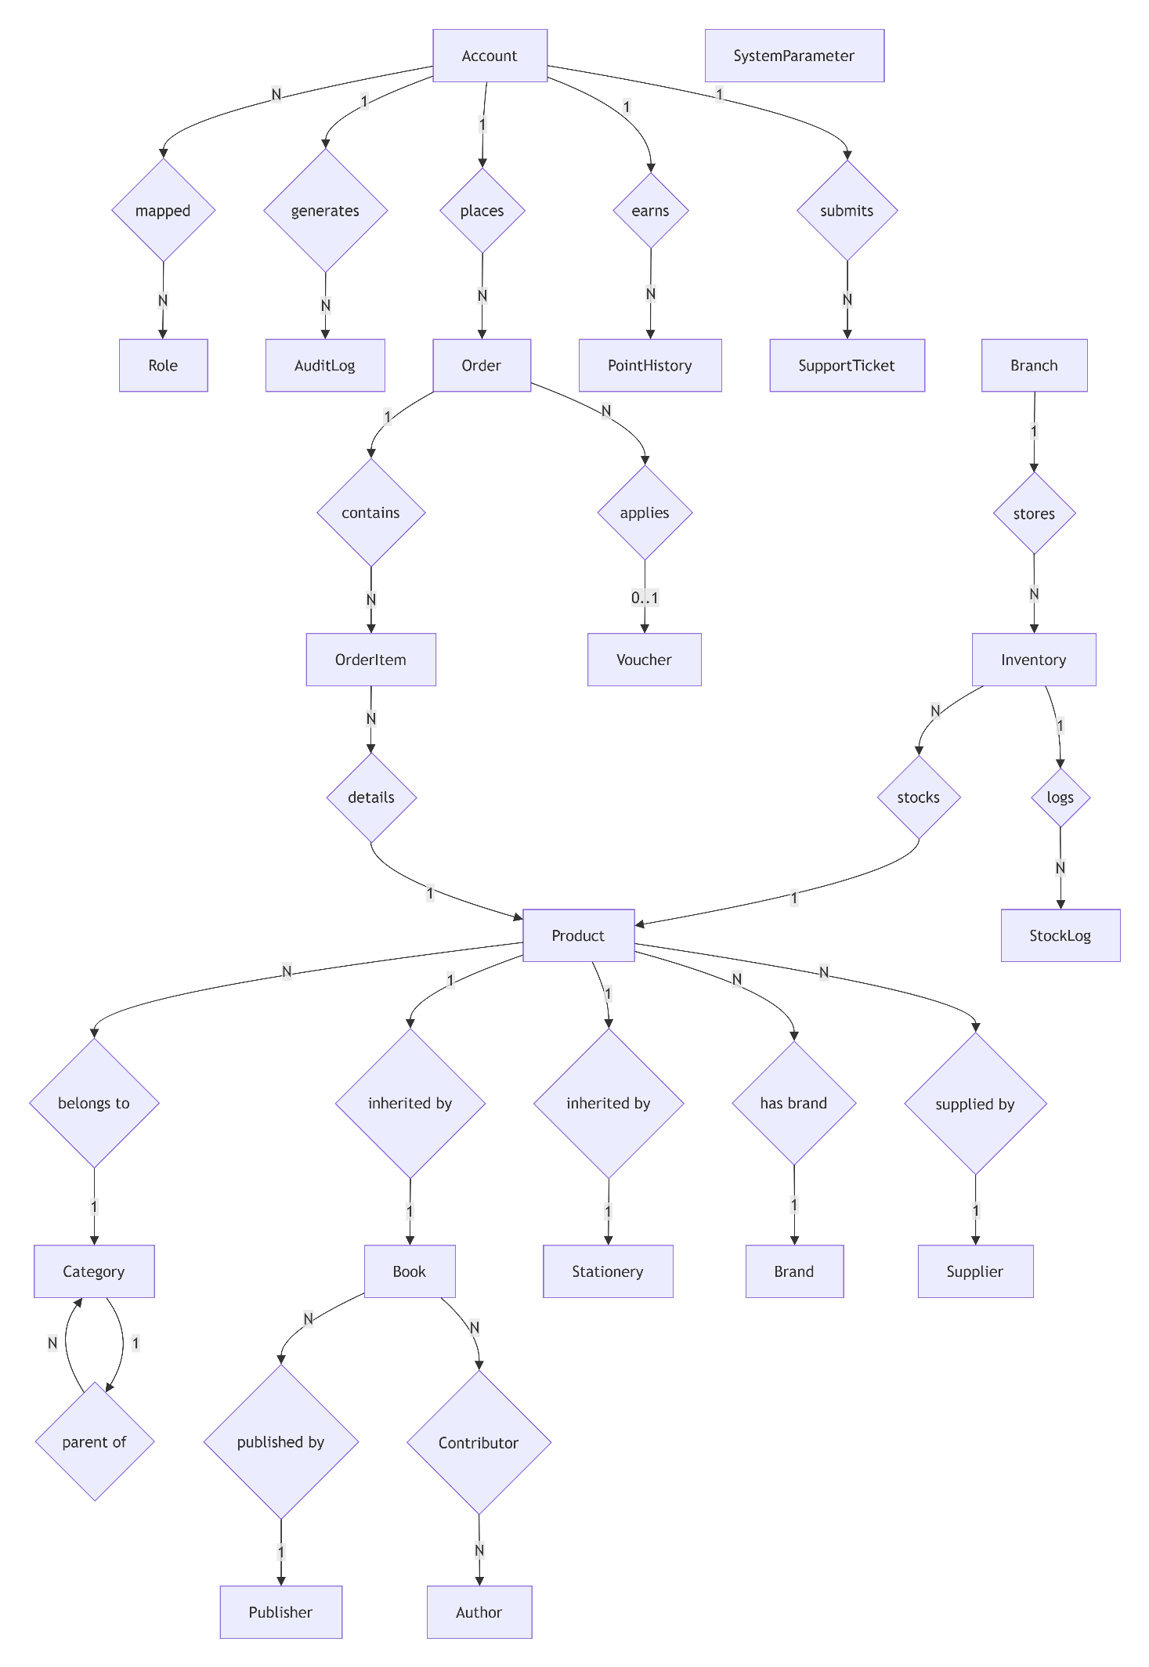
Figure 2. Overall Logical Data Model of the Mini Fahasa.
The logical data model consists of the following core entities:
- SystemParameter & AuditLog: Stores system configuration parameters and security logs for administrators.
- Account & Role: Manages users, mapped N-N with Role for authorization.
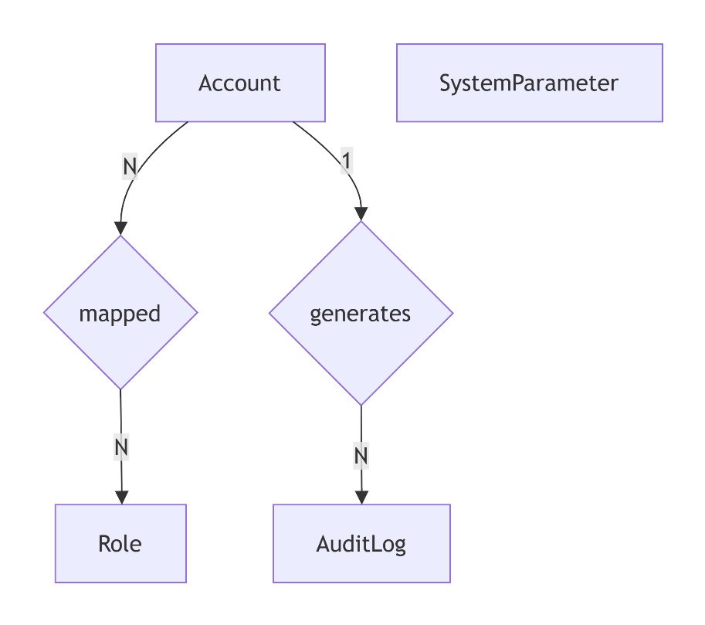
Figure 3. Logical Data Model for User Management and Security.
- Product Hierarchy: Product entity (Parent) inherited by Book and Stationery (Child). Links to Category (recursive parent-child), Publisher, Brand, Supplier.
- Contributor: N-N linking table between Book and Author.
- Branch: Stores warehouse branch info.
- Category: Stores recursive product categories (parent-child).
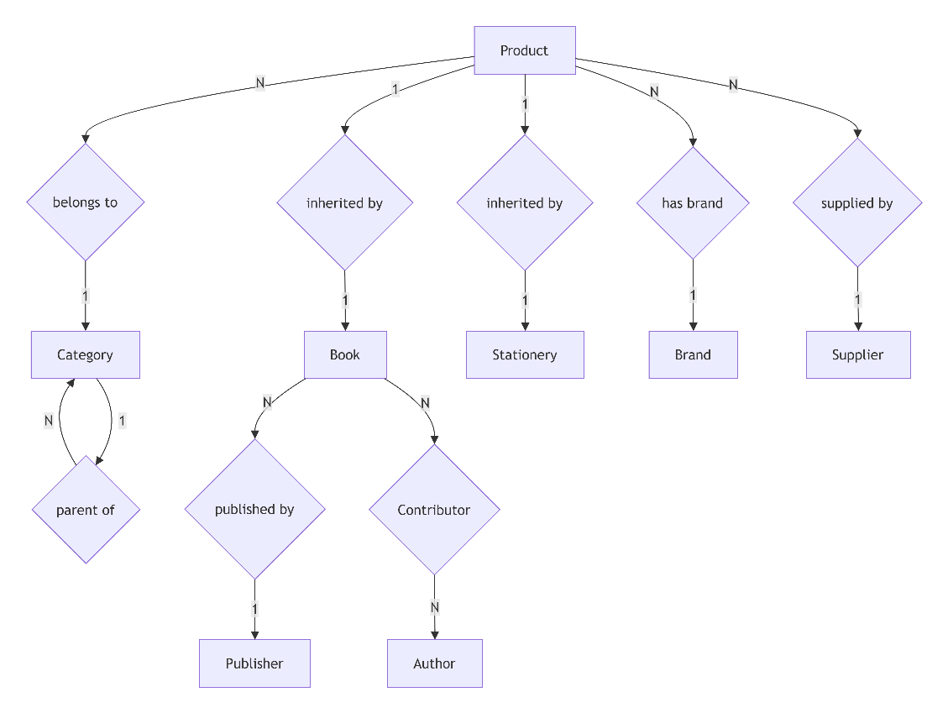
Figure 4. Logical Data Model for Product Catalog and Hierarchy.
- Order & OrderItem: Order stores general info (total price, status, address, voucher, account), OrderItem stores detailed purchased products and quantities. Order links optionally (Nullable) to Voucher.
- Voucher: Stores discount code info (code, percentage, expiry date, usage limits).
- PointHistory: Stores loyalty points transaction history for each Customer.
- SupportTicket: Stores customer support requests, complaints, returns/exchanges.
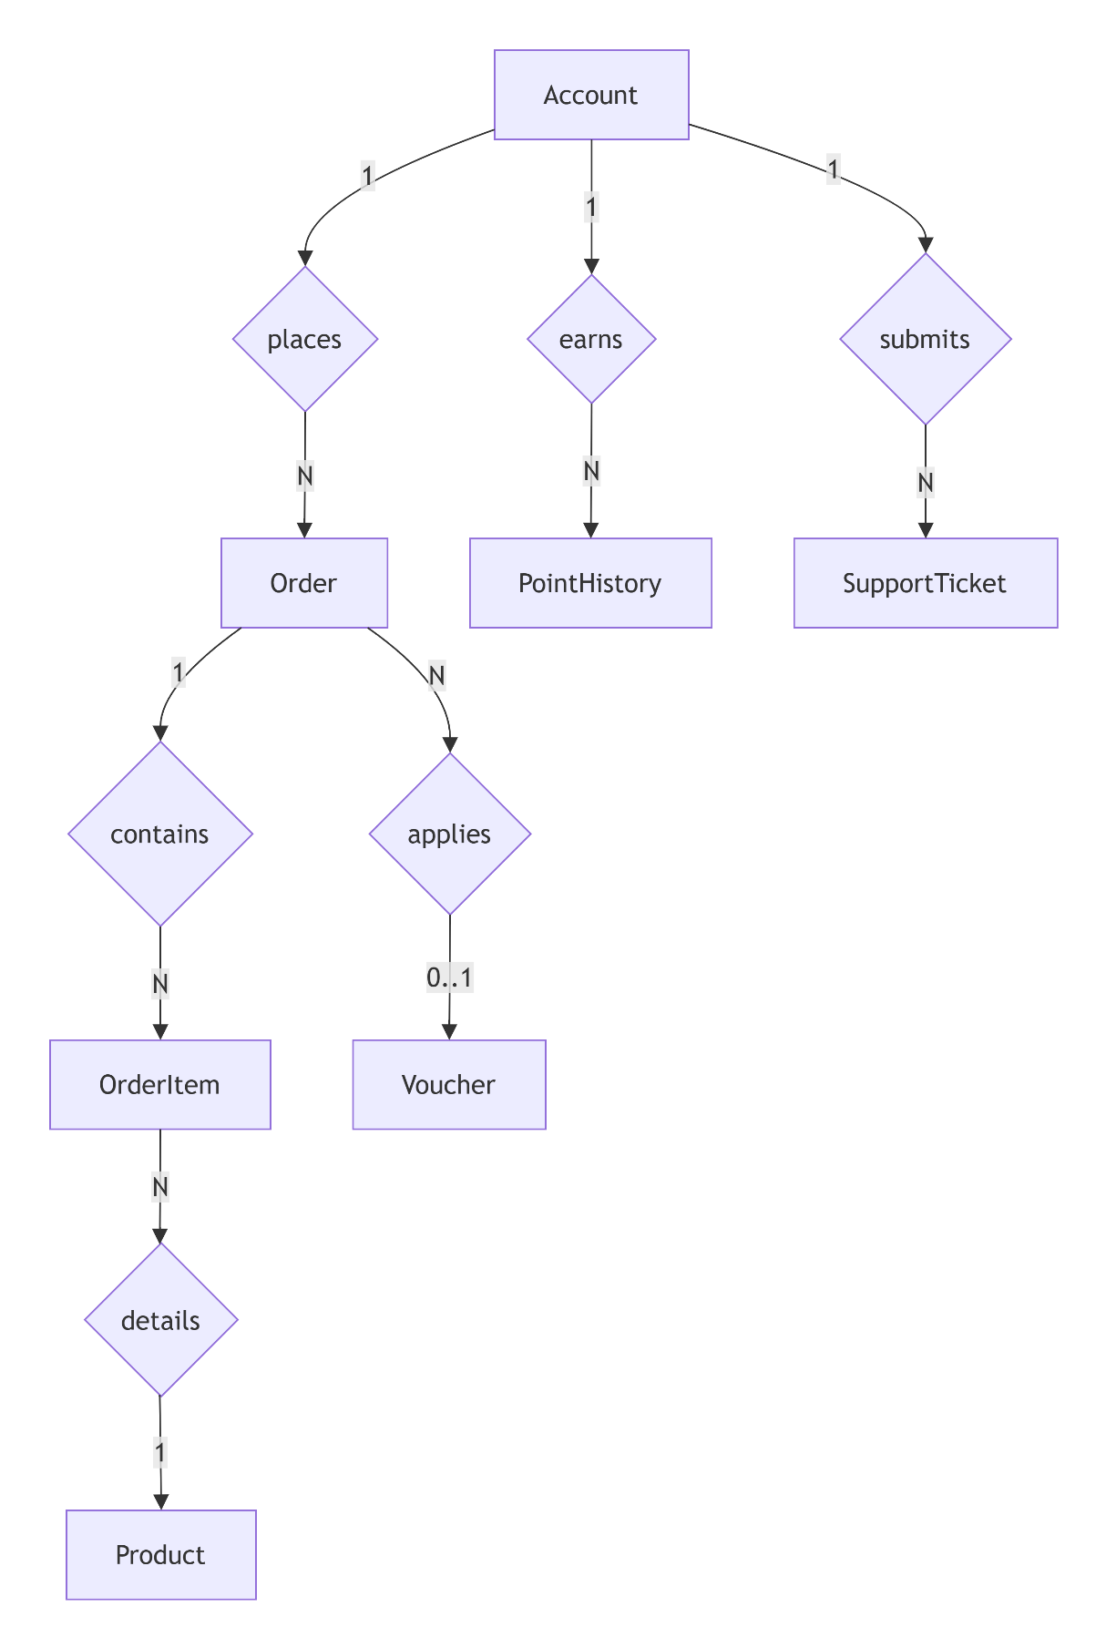
Figure 5. Logical Data Model for Order Management and Customer Support.
- Inventory & StockLog: Inventory entity stores current stock per Branch, along with last_import_quantity to calculate the alert threshold (BR-04). StockLog stores export/import/adjustment history along with reasons (reason).
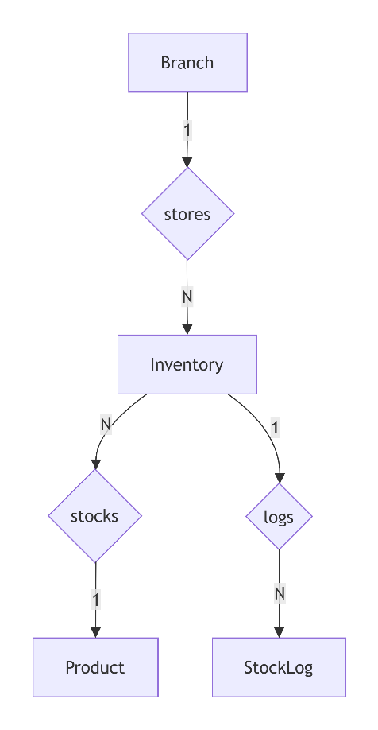
Figure 6. Logical Data Model for Inventory and Warehouse Management.

4.2 Data Dictionary

Account Table
Field | Data Type | Required | Constraint | Default Value | Notes
id | INT | ✅ | PK, Auto Increment | — | Primary Key
email | VARCHAR(100) | ✅ | UNIQUE, RFC 5322 format | — | Used for login
password | VARCHAR(255) | ✅ | Min 8 chars, 1 uppercase, 1 lowercase, 1 number | — | Stores BCrypt hash
fullname | VARCHAR(150) | ✅ | — | — | User's full name
phone | VARCHAR(10) | ✅ | Regex:  ^0[0-9]{9}$ | — | Phone number
dob | DATE | ✅ | Age $≥15$ (BR-16) | — | Format YYYY-MM-DD
points | INT | ✅ | $$≥0$$ | 0 | Loyalty points
is_active | BOOLEAN | ✅ | — | TRUE | FALSE = Account disabled
created_at | DATETIME | ✅ | — | CURRENT_TIMESTAMP | Account creation date

Role Table
Field | Data Type | Required | Constraint | Default Value | Notes
id | INT | ✅ | PK, Auto Increment | ✅ | Primary Key
name | VARCHAR(50) | ✅ | UNIQUE | ✅ | Admin, Manager, Sale, CS, Customer

Note: Account and Role have an N-N relationship, managed via an intermediate Account_Role table (account_id FK, role_id FK) — no direct role_id column needed in Account.

Category Table
Field | Data Type | Required | Constraint | Default Value | Notes
id | INT | ✅ | PK, Auto Increment | — | Primary Key
parent_id | INT | ❌ | FK Category(id), Nullable | NULL | NULL = Root category
name | VARCHAR(100) | ✅ | UNIQUE within same parent | — | Category name

Branch Table
Field | Data Type | Required | Constraint | Default Value | Notes
id | INT | ✅ | PK, Auto Increment | — | Primary Key
name | VARCHAR(100) | ✅ | — | — | Branch name
address | VARCHAR(500) | ✅ | — | — | Branch address

Product Table
Field | Data Type | Required | Constraint | Default Value | Notes
id | INT | ✅ | PK, Auto Increment | — | Primary Key
category_id | INT | ✅ | FK Category(id) | — | Linked category
title | VARCHAR(255) | ✅ | UNIQUE within same category | — | Product name
price | DECIMAL(12,2) | ✅ | $$>0$$ | — | Avoid FLOAT to prevent precision loss
description | TEXT | ❌ | — | NULL | Detailed description
is_deleted | BOOLEAN | ✅ | — | FALSE | Soft delete
created_at | DATETIME | ✅ | — | CURRENT_TIMESTAMP | Creation date

Book Table (inherits Product)
Field | Data Type | Required | Constraint | Default Value | Notes
product_id | INT | ✅ | PK, FK Product(id) | — | PK and FK
publisher_id | INT | ❌ | FK Publisher(id) | NULL | Publisher
isbn | VARCHAR(20) | ❌ | UNIQUE | NULL | ISBN code
translator | VARCHAR(150) | ❌ | — | NULL | Translator
publication_year | INT | ❌ | $$>0$$ | NULL | Publication year
language | VARCHAR(50) | ❌ | — | NULL | Language

Stationery Table (inherits Product)
Field | Data Type | Required | Constraint | Default Value | Notes
product_id | INT | ✅ | PK, FK Product(id) | — | PK and FK
brand_id | INT | ✅ | FK Brand(id) | — | Brand
color | VARCHAR(50) | ❌ | — | NULL | Color
material | VARCHAR(100) | ❌ | — | NULL | Material
specifications | VARCHAR(255) | ❌ | — | NULL | Specifications
warning | VARCHAR(255) | ❌ | — | NULL | Usage warning

Author Table
Field | Data Type | Required | Constraint | Default Value | Notes
id | INT | ✅ | PK, Auto Increment | — | Primary Key
name | VARCHAR(150) | ✅ | — | — | Author name
biography | TEXT | ❌ | — | NULL | Biography

Contributor Table (Book - Author Link)
Field | Data Type | Required | Constraint | Default Value | Notes
book_id | INT | ✅ | PK, FK Book(product_id) | — | FK to Book
author_id | INT | ✅ | PK, FK Author(id) | — | FK to Author
role | VARCHAR(50) | ❌ | — | NULL | Role (e.g., Author, Translator)

Publisher Table
Field | Data Type | Required | Constraint | Default Value | Notes
id | INT | ✅ | PK, Auto Increment | — | Primary Key
name | VARCHAR(150) | ✅ | UNIQUE | — | Publisher name
address | VARCHAR(255) | ❌ | — | NULL | Address

Brand Table
Field | Data Type | Required | Constraint | Default Value | Notes
id | INT | ✅ | PK, Auto Increment | — | Primary Key
name | VARCHAR(150) | ✅ | UNIQUE | — | Brand name
country | VARCHAR(100) | ❌ | — | NULL | Country

Supplier Table
Field | Data Type | Required | Constraint | Default Value | Notes
id | INT | ✅ | PK, Auto Increment | — | Primary Key
name | VARCHAR(150) | ✅ | UNIQUE | — | Supplier name
contact_email | VARCHAR(100) | ❌ | — | NULL | Contact email
phone | VARCHAR(20) | ❌ | — | NULL | Phone number

Cart Table
Field | Data Type | Required | Constraint | Default Value | Notes
id | INT | ✅ | PK, Auto Increment | — | Primary Key
account_id | INT | ✅ | UNIQUE, FK Account(id) | — | Whose cart
updated_at | DATETIME | ✅ | — | CURRENT_TIMESTAMP | Last update time

CartItem Table
Field | Data Type | Required | Constraint | Default Value | Notes
cart_id | INT | ✅ | PK, FK Cart(id) | — | Belongs to which cart
product_id | INT | ✅ | PK, FK Product(id) | — | Which product
quantity | INT | ✅ | $$>0$$ | 1 | Quantity

Voucher (Discount) Table
Field | Data Type | Required | Constraint | Default Value | Notes
id | INT | ✅ | PK, Auto Increment | — | Primary Key
code | VARCHAR(50) | ✅ | UNIQUE | — | Voucher code (e.g., FAHASA20)
discount_percent | DECIMAL(5,2) | ✅ | $>0$, $≤100$ | — | Discount percentage
max_discount_amount | DECIMAL(12,2) | ❌ | $$≥0$$ | NULL | Max discount amount (NULL = no limit)
start_date | DATE | ✅ | — | — | Validity start date
expiry_date | DATE | ✅ | $>$ start_date | — | Expiry date
usage_limit | INT | ✅ | $$≥0$$ | — | Max number of usages (0 = no limit)
usage_count | INT | ✅ | $$≥0$$ | 0 | Number of times used
is_active | BOOLEAN | ✅ | — | TRUE | FALSE = Voucher disabled

Order Table
Field | Data Type | Required | Constraint | Default Value | Notes
id | INT | ✅ | PK, Auto Increment | — | Primary Key
account_id | INT | ✅ | FK Account(id) | — | Customer who ordered
voucher_id | INT | ❌ | FK Voucher(id), Nullable | NULL | Applied voucher code (if any)
total_price | DECIMAL(12,2) | ✅ | $$>0$$ | — | Total amount after discounts
status | ENUM | ✅ | PENDING, CONFIRMED, SHIPPING, DELIVERED, CANCELLED | PENDING | Order status
payment_method | ENUM | ✅ | COD, VNPAY | — | Payment method
shipping_address | VARCHAR(500) | ✅ | — | — | Delivery address
created_at | DATETIME | ✅ | — | CURRENT_TIMESTAMP | Creation time

OrderItem Table
Field | Data Type | Required | Constraint | Default Value | Notes
id | INT | ✅ | PK, Auto Increment | — | Primary Key
order_id | INT | ✅ | FK Order(id) | — | Order ID
product_id | INT | ✅ | FK Product(id) | — | Product ID
quantity | INT | ✅ | $$>0$$ | — | Quantity purchased
price | DECIMAL(12,2) | ✅ | $$≥0$$ | — | Unit price at time of purchase (snapshot)

PointHistory Table
Field | Data Type | Required | Constraint | Default Value | Notes
id | INT | ✅ | PK, Auto Increment | — | Primary Key
account_id | INT | ✅ | FK Account(id) | — | Account with points change
order_id | INT | ❌ | FK Order(id), Nullable | NULL | Related order (if any)
points_change | INT | ✅ | — | — | Points change (+ add, - deduct)
reason | VARCHAR(255) | ✅ | — | — | Reason: "Order #X", "Redeem voucher", "Refund cancelled order"
created_at | DATETIME | ✅ | — | CURRENT_TIMESTAMP | Change time

Inventory Table
Field | Data Type | Required | Constraint | Default Value | Notes
product_id | INT | ✅ | PK, FK Product(id) | — | Product ID
branch_id | INT | ✅ | PK, FK Branch(id) | — | Warehouse branch ID
stock_quantity | INT | ✅ | $$≥0$$ | 0 | Actual stock quantity
last_import_quantity | INT | ❌ | — | NULL | Last import quantity. Used for "Low stock" alert = 10% Ã— this value (BR-04)

StockLog Table
Field | Data Type | Required | Constraint | Default Value | Notes
id | INT | ✅ | PK, Auto Increment | — | Primary Key
product_id | INT | ✅ | FK Product(id) | — | Product ID changed
type | ENUM | ✅ | IMPORT, EXPORT, ORDER_DEDUCT, ORDER_RETURN, DEFECTIVE_RETURN | — | Transaction type
quantity_change | INT | ✅ | — | — | Quantity change (+ or -)
executor_id | INT | ✅ | FK Account(id) | — | User who executed transaction
reason | VARCHAR(500) | ❌ | — | NULL | Notes/Reason (e.g., "Cancel order #123", "Defective goods from Supplier")
created_at | DATETIME | ✅ | — | CURRENT_TIMESTAMP | Transaction time

SupportTicket Table
Field | Data Type | Required | Constraint | Default Value | Notes
id | INT | ✅ | PK, Auto Increment | — | Primary Key
account_id | INT | ✅ | FK Account(id) | — | Customer who created Ticket
order_id | INT | ❌ | FK Order(id), Nullable | NULL | Related order (optional)
subject | VARCHAR(255) | ✅ | — | — | Request subject
description | TEXT | ✅ | — | — | Detailed description
status | ENUM | ✅ | OPEN, IN_PROGRESS, RESOLVED, CLOSED | OPEN | Ticket status
created_by_staff | INT | ❌ | FK Account(id), Nullable | NULL | CS Staff who created it on behalf of customer (UC-39). NULL = Customer created
created_at | DATETIME | ✅ | — | CURRENT_TIMESTAMP | Creation time

SystemParameter Table
Field | Data Type | Required | Constraint | Default Value | Notes
id | INT | ✅ | PK, Auto Increment | — | Primary Key
param_key | VARCHAR(100) | ✅ | UNIQUE | — | Constant name (e.g., LIMIT_AGE, SLA_DAYS)
param_value | VARCHAR(255) | ✅ | — | — | System config value
description | VARCHAR(500) | ❌ | — | NULL | Parameter function description
updated_at | DATETIME | ✅ | — | CURRENT_TIMESTAMP | Last update time

AuditLog Table
Field | Data Type | Required | Constraint | Default Value | Notes
id | INT | ✅ | PK, Auto Increment | — | Primary Key
actor_id | INT | ✅ | FK Account(id) | — | User who performed action
action | VARCHAR(150) | ✅ | — | — | Name of executed action
details | TEXT | ✅ | — | — | Detailed log description
ip_address | VARCHAR(50) | ❌ | — | NULL | Accessing IP address
created_at | DATETIME | ✅ | — | CURRENT_TIMESTAMP | Log recording time

4.3 Reports

4.3.1 Monthly Revenue & Best-Selling Product Report
Report ID: | REV-R-1
Report Title: | Monthly Revenue and Best-Selling Product Report
Report Purpose: | The Manager wants to track total revenue, payment method proportion, and best-selling products for business strategy.
Priority: | High
Report Users: | Manager, Sales Manager
Data Sources: | Order, Payment, and Product database of the corresponding month.
Frequency and Disposition: | Automatically generated on the last day of each month. Displayed on Dashboard and exportable to PDF/Excel.
Latency: | Displayed within 3 seconds (Ensured by Database Indexing on created_at, status and Redis Caching for heavy calculations).
Visual Layout: | Portrait / Landscape (A4)
Header and Footer: | Header contains report title and month. Footer contains page numbers.
Report Body: | - Total revenue by day/month/year.  - Revenue percentage by payment method: COD vs VNPay.  - List of Best-Selling products (> 50 units sold/month per BR-13).  - Best-Sellers categorized into 3 price segments (Under 500k, 500k-1M, Over 1M VND per BR-05).
Interactivity: | The user can click on a best-selling product to view its detailed revenue statistics.
Security Access Restrictions: | Only Manager and Sales Manager can view revenue and profit data.

4.3.2 Inventory Status & Low Stock Report
Report ID: | INV-R-1
Report Title: | Inventory Status and Low Stock Report
Report Purpose: | To control inventory levels, receive early warnings on low-stock items for restock or branch transfers (BR-07).
Priority: | High
Report Users: | Manager, Store Manager
Data Sources: | Product, Inventory, and StockLog database.
Frequency and Disposition: | Generated on-demand or monthly. Displayed on system screens.
Latency: | Displayed within 3 seconds (Ensured by Database Indexing on created_at, status and Redis Caching for heavy calculations).
Visual Layout: | Portrait / Landscape (A4)
Header and Footer: | Header contains report title and month. Footer contains page numbers.
Report Body: | - Current inventory quantities grouped by branch.  - List of low-stock products (inventory drops below 10% of the last import quantity per BR-04).  - Stock variation history (StockLog).
Interactivity: | Users can filter inventory by specific branches or filter only low-stock alerts.
Security Access Restrictions: | Manager and Store Manager have the right to view branch inventory data.

4.3.3 Order Status & Performance Report
Report ID: | ORD-R-1
Report Title: | Order Status and Performance Report
Report Purpose: | To evaluate order processing efficiency and delivery status.
Priority: | Medium
Report Users: | Manager, Operations Manager
Data Sources: | Order and AuditLog table (to trace order status transition history).
Frequency and Disposition: | On-demand or monthly synthesis.
Latency: | Displayed within 3 seconds (Ensured by Database Indexing on created_at, status and Redis Caching for heavy calculations).
Visual Layout: | Portrait / Landscape (A4)
Header and Footer: | Header contains report title and month. Footer contains page numbers.
Report Body: | - Total orders grouped by status (PENDING, CONFIRMED, SHIPPING, DELIVERED, CANCELLED).  - Successful delivery rate.  - Order cancellation rate.  - Average order processing time.
Interactivity: | Users can click on a status (e.g., CANCELLED) to view the list of corresponding orders.
Security Access Restrictions: | Manager and Operations Manager are allowed to view this report.

4.3.4 Payment Reconciliation Report
Report ID: | PAY-R-1
Report Title: | VNPay Payment Reconciliation Report
Report Purpose: | To reconcile internal financial data with the VNPay gateway, identifying discrepancies or hanging transactions.
Priority: | High
Report Users: | Manager, Finance Manager
Data Sources: | Order, Payment, and AuditLog table (storing VNPay IPN logs as JSON).
Frequency and Disposition: | Automatically generated daily or on-demand.
Latency: | Displayed within 3 seconds (Ensured by Database Indexing on created_at, status and Redis Caching for heavy calculations).
Visual Layout: | Portrait / Landscape (A4)
Header and Footer: | Header contains report title and month. Footer contains page numbers.
Report Body: | - Actual revenue recorded by VNPay versus total value of DELIVERED orders paid via VNPay.  - List of hanging transactions (transactions without IPN callback from VNPay).  - Discrepancy table highlighting differences between internal system and VNPay gateway.
Interactivity: | Click on a hanging transaction ID to view its detailed IPN logs.
Security Access Restrictions: | Only Manager and Finance Manager can access this financial report.

4.3.1 Monthly Revenue & Best-Selling Product Report
Report ID: | REV-R-1
Report Title: | Monthly Revenue and Best-Selling Product Report
Report Purpose: | The Manager wants to track total revenue, payment method proportion, and best-selling products for business strategy.
Priority: | High
Report Users: | Manager, Sales Manager
Data Sources: | Order, Payment, and Product database of the corresponding month.
Frequency and Disposition: | Automatically generated on the last day of each month. Displayed on Dashboard and exportable to PDF/Excel.
Latency: | Displayed within 3 seconds (Ensured by Database Indexing on created_at, status and Redis Caching for heavy calculations).
Visual Layout: | Portrait / Landscape (A4)
Header and Footer: | Header contains report title and month. Footer contains page numbers.
Report Body: | - Total revenue by day/month/year.  - Revenue percentage by payment method: COD vs VNPay.  - List of Best-Selling products (> 50 units sold/month per BR-13).  - Best-Sellers categorized into 3 price segments (Under 500k, 500k-1M, Over 1M VND per BR-05).
Interactivity: | The user can click on a best-selling product to view its detailed revenue statistics.
Security Access Restrictions: | Only Manager and Sales Manager can view revenue and profit data.

4.3.2 Inventory Status & Low Stock Report
Report ID: | INV-R-1
Report Title: | Inventory Status and Low Stock Report
Report Purpose: | To control inventory levels, receive early warnings on low-stock items for restock or branch transfers (BR-07).
Priority: | High
Report Users: | Manager, Store Manager
Data Sources: | Product, Inventory, and StockLog database.
Frequency and Disposition: | Generated on-demand or monthly. Displayed on system screens.
Latency: | Displayed within 3 seconds (Ensured by Database Indexing on created_at, status and Redis Caching for heavy calculations).
Visual Layout: | Portrait / Landscape (A4)
Header and Footer: | Header contains report title and month. Footer contains page numbers.
Report Body: | - Current inventory quantities grouped by branch.  - List of low-stock products (inventory drops below 10% of the last import quantity per BR-04).  - Stock variation history (StockLog).
Interactivity: | Users can filter inventory by specific branches or filter only low-stock alerts.
Security Access Restrictions: | Manager and Store Manager have the right to view branch inventory data.

4.3.3 Order Status & Performance Report
Report ID: | ORD-R-1
Report Title: | Order Status and Performance Report
Report Purpose: | To evaluate order processing efficiency and delivery status.
Priority: | Medium
Report Users: | Manager, Operations Manager
Data Sources: | Order and AuditLog table (to trace order status transition history).
Frequency and Disposition: | On-demand or monthly synthesis.
Latency: | Displayed within 3 seconds (Ensured by Database Indexing on created_at, status and Redis Caching for heavy calculations).
Visual Layout: | Portrait / Landscape (A4)
Header and Footer: | Header contains report title and month. Footer contains page numbers.
Report Body: | - Total orders grouped by status (PENDING, CONFIRMED, SHIPPING, DELIVERED, CANCELLED).  - Successful delivery rate.  - Order cancellation rate.  - Average order processing time.
Interactivity: | Users can click on a status (e.g., CANCELLED) to view the list of corresponding orders.
Security Access Restrictions: | Manager and Operations Manager are allowed to view this report.

4.3.4 Payment Reconciliation Report
Report ID: | PAY-R-1
Report Title: | VNPay Payment Reconciliation Report
Report Purpose: | To reconcile internal financial data with the VNPay gateway, identifying discrepancies or hanging transactions.
Priority: | High
Report Users: | Manager, Finance Manager
Data Sources: | Order, Payment, and AuditLog table (storing VNPay IPN logs as JSON).
Frequency and Disposition: | Automatically generated daily or on-demand.
Latency: | Displayed within 3 seconds (Ensured by Database Indexing on created_at, status and Redis Caching for heavy calculations).
Visual Layout: | Portrait / Landscape (A4)
Header and Footer: | Header contains report title and month. Footer contains page numbers.
Report Body: | - Actual revenue recorded by VNPay versus total value of DELIVERED orders paid via VNPay.  - List of hanging transactions (transactions without IPN callback from VNPay).  - Discrepancy table highlighting differences between internal system and VNPay gateway.
Interactivity: | Click on a hanging transaction ID to view its detailed IPN logs.
Security Access Restrictions: | Only Manager and Finance Manager can access this financial report.

4.4 Data Integrity, Retention, and Disposal
- DIS-01: All operations related to creating an Order (reducing StockQuantity, creating Order, creating OrderItem) and Cancelling an order must be executed within a Database Transaction. If an error occurs, it automatically rolls back.
- DIS-02: Order history, payment history, and StockLogs are never completely deleted from the DB (Soft Delete or Archive) for financial reconciliation and auditing purposes.
- DIS-03: The AuditLog table is Immutable (no UPDATE or DELETE allowed), INSERT only.

5. External Interface Requirements

5.1 User Interfaces

Storefront (Customer Interface):
- Designed in a Minimalist style, primary white background (#FFFFFF), with prominent product images.
- Main screens:
  - [UI-SF-HOME] Homepage: Promo banners, Featured products, Best Sellers.
  - [UI-SF-SEARCH] Search & Filter products: Category filter, Price range, Author/Brand.
  - [UI-SF-DETAIL] Product Details: Images, Description, Price, "Add to cart" button, "Best Seller" / "Low Stock" badges.
  - [UI-SF-CART] Cart: List of products, Subtotal, "Checkout" button.
  - [UI-SF-CHECKOUT] Checkout: Shipping address form, Select payment method, Enter Voucher/Redeem points.
  - [UI-SF-TRACKING] Order Tracking: Status timeline (PENDING DELIVERED).
  - [UI-SF-TICKET] Submit support request / Return/Exchange.
  - [UI-SF-PROFILE] View/Edit personal profile and loyalty points balance.
- Client-side Validation: All input forms must undergo validation on the Client side (JavaScript) before sending requests to the Server. Includes: Email format, Phone format, password strength, image size limits.
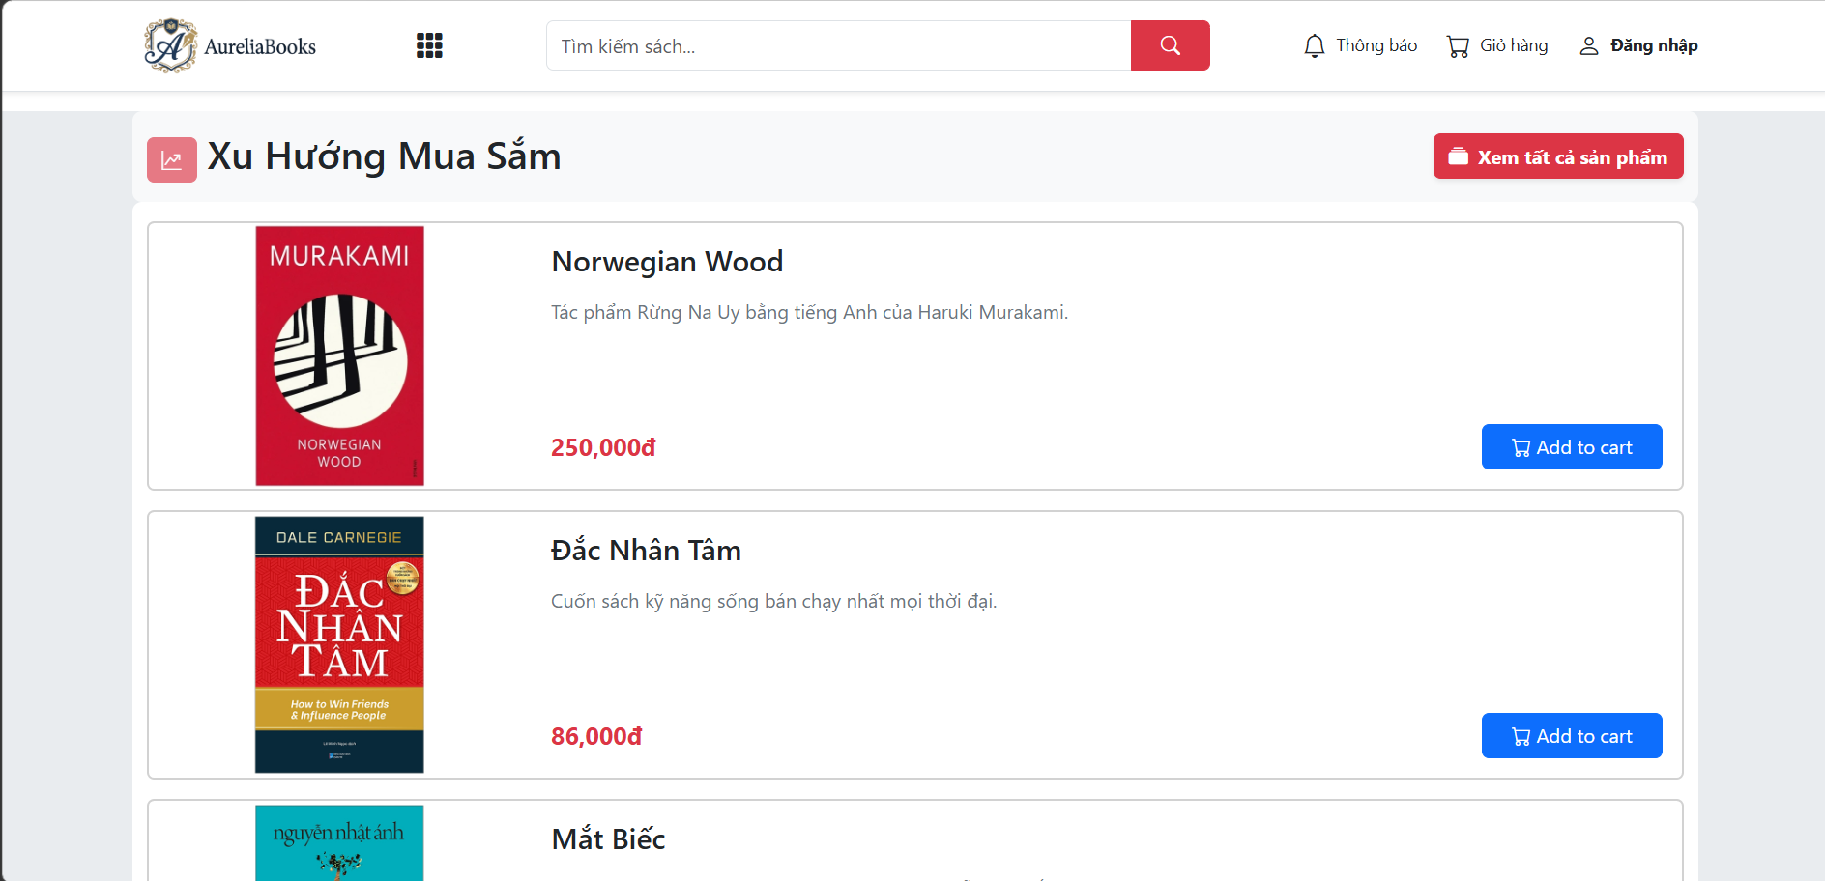
Figure 7. Prototype 1.
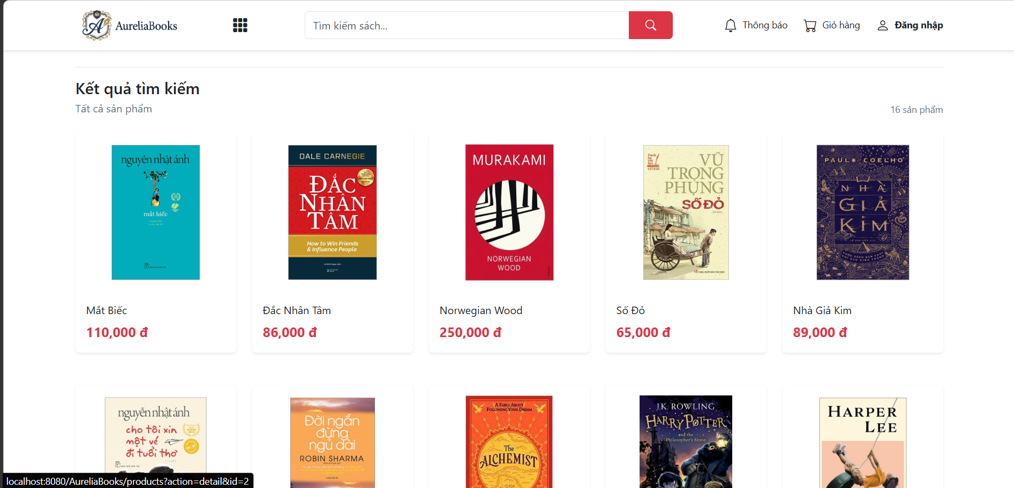
Figure 8. Prototype 2

Dashboard (Staff/Manager Interface):
- Left Sidebar interface containing the navigation menu.
- Main screens:
  - [UI-DB-ORDER] Order Management: Order list table, filter by status, switch status button.
  - [UI-DB-PRODUCT] Product Management: Product CRUD, image uploads.
  - [UI-DB-INVENTORY] Inventory Management: Inventory table by branch, adjustment form, StockLog history, low stock alerts.
  - [UI-DB-TICKET] Support Ticket Management: Ticket list, overdue SLA warning badge, ticket statistics.
  - [UI-DB-REPORT] Reports: Revenue charts, Best Seller, Inventory, Orders, Payment Reconciliation.
  - [UI-DB-ACCOUNT] Account Management (Admin only).
  - [UI-DB-CONFIG] System Parameter Configuration (Admin only).
  - [UI-DB-AUDIT] View System Logs (Admin only).
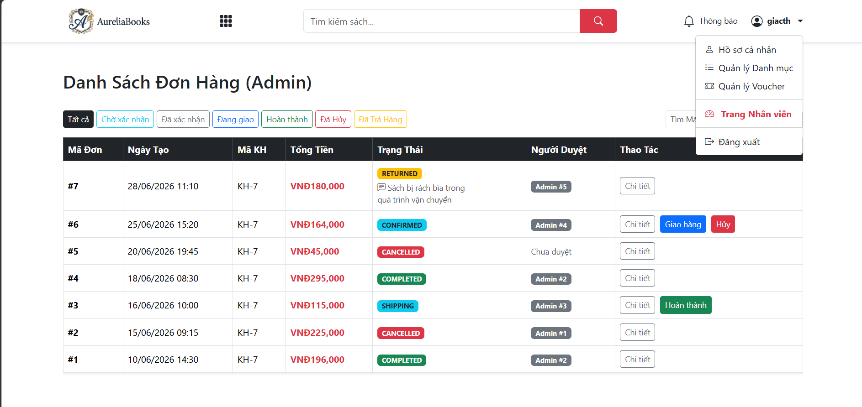
Figure 9. Prototype 3
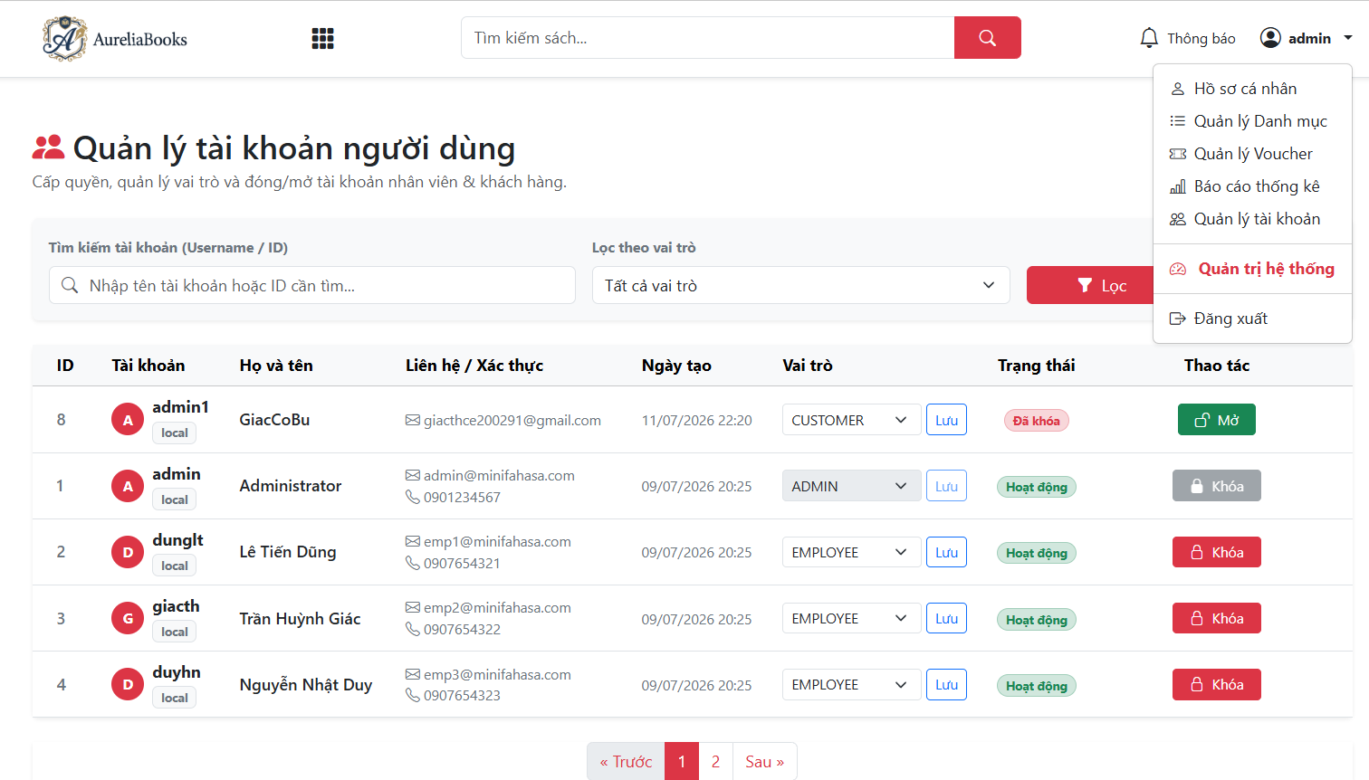
Figure 10. Prototype 4

5.2 Software Interfaces

Google OAuth 2.0 API:
- Purpose: Allows Customers to log in using a Google account (SSO) (UC-06).
- Protocol: OAuth 2.0 Authorization Code Flow.
- Endpoint: https://accounts.google.com/o/oauth2/v2/auth
- Received Data: email, name, profile_picture.
- Constraints: Must register OAuth 2.0 Credentials on the Google Cloud Console. Client ID and Client Secret stored in Environment Variables (CO-3).

VNPay Sandbox API:
- Purpose: Process online payments (testing environment) (UC-15).
- Protocol: HTTPS POST/GET with SHA256/HMAC signature.
- Timeout: 10 seconds per request.
- Retry Policy: Max 3 retries, 2 seconds between each attempt.
- IPN Webhook: Backend must expose endpoint /api/v1/payment/vnpay-ipn to receive Instant Payment Notification callback from VNPay.
- Constraints: VNPay API Key and Secret Hash stored in Environment Variables (CO-3). Backend must verify IPN signature before updating payment status.

5.3 Hardware Interfaces
No special hardware requirements on the Client side. On the Server side, hardware must ensure CPU and RAM capacity to run Java Spring Boot, handling up to 100 concurrent connections.

5.4 Communications Interfaces
- All connections between Client and Server must be over HTTPS (unencrypted HTTP is blocked in Production environment).
- Backend API provided as RESTful JSON. Authentication based on HTTP Header Authorization: Bearer <JWT>.
- CORS Policy: Backend only accepts requests from Frontend domains configured in the whitelist.

6. Quality Attributes

6.1 Usability Requirements
- USE-01: The system supports Responsive Design, easily operable across Desktop, Tablet, and Mobile.
- USE-02: Sale Staff must be able to confirm an order with a maximum of 2 mouse clicks from the order list to meet the BO-1 target (increase processing speed).

6.2 Performance Requirements
- PER-01: The system must respond to search and catalog browsing requests in under 2 seconds.
- PER-02: Processing the Checkout flow (including DB writing and 3rd-party API calls) must not exceed 5 seconds.

6.3 Security Requirements
- SEC-01: Passwords stored in the database must be one-way encrypted (e.g., BCrypt).
- SEC-02: API endpoints must verify the JWT and role (RBAC) before allowing logic execution.
- SEC-03: Block "Read-only" actions from becoming "Write" for CS Staff at the API level.

6.4 Safety Requirements
- SAF-01: A Pessimistic Locking or Optimistic Locking mechanism must be applied to the Inventory table to prevent Race Condition errors when multiple customers simultaneously purchase an item with only 1 unit left in stock.

6.5 Availability Requirements
- AVL-01: The Backend system and Database must achieve a minimum availability of 99.9% (excluding pre-announced maintenance periods).

6.6 Robustness Requirements
- ROB-01: If the VNPay API responds with a timeout, the system automatically keeps the order status as PENDING and alerts the customer to try again or switch to COD.

Appendix A: Analysis Models

1. Use Case Diagram
Represents the Actors (Guest, Customer, Sale Staff, CS Staff, Manager, Admin) interacting with the Use Cases within the system. See details in the attached Use_Case_Diagram.html file in the documentation package.

[UseCase]

2. Entity Relationship Diagram (ERD)
The Logical Data Model showing the core database structure of the Mini Fahasa system.
SWR302 - ERD - dbdiagram.io
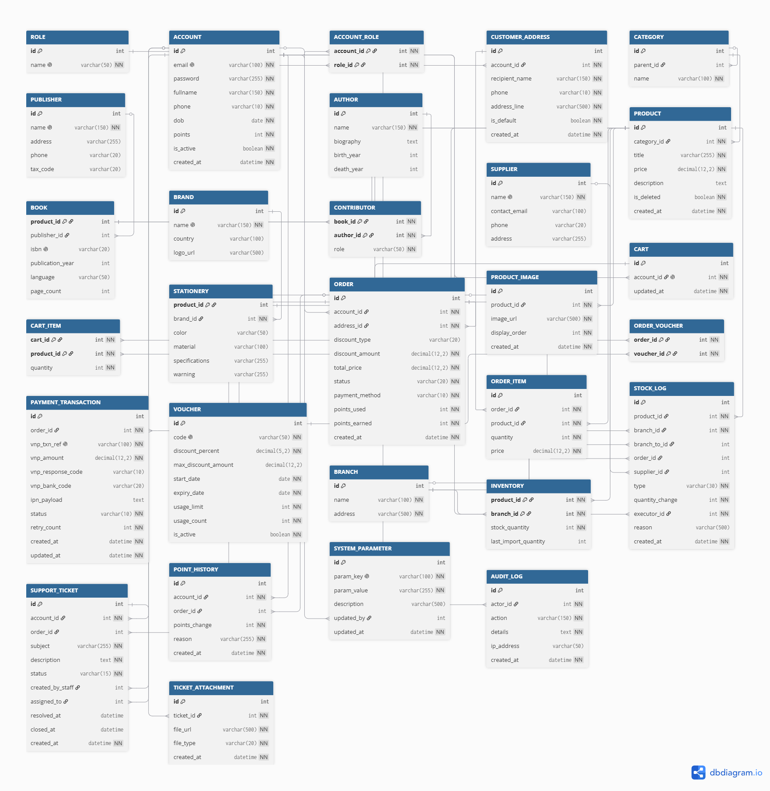
Figure 11. Entity Relationship Diagram (ERD)

3. Checkout Flow (Activity Diagram)
Activity diagram for the checkout process, illustrating the application of promotional business rules (BR-09, BR-10, BR-14) and inventory verification, payment (VNPay / COD).
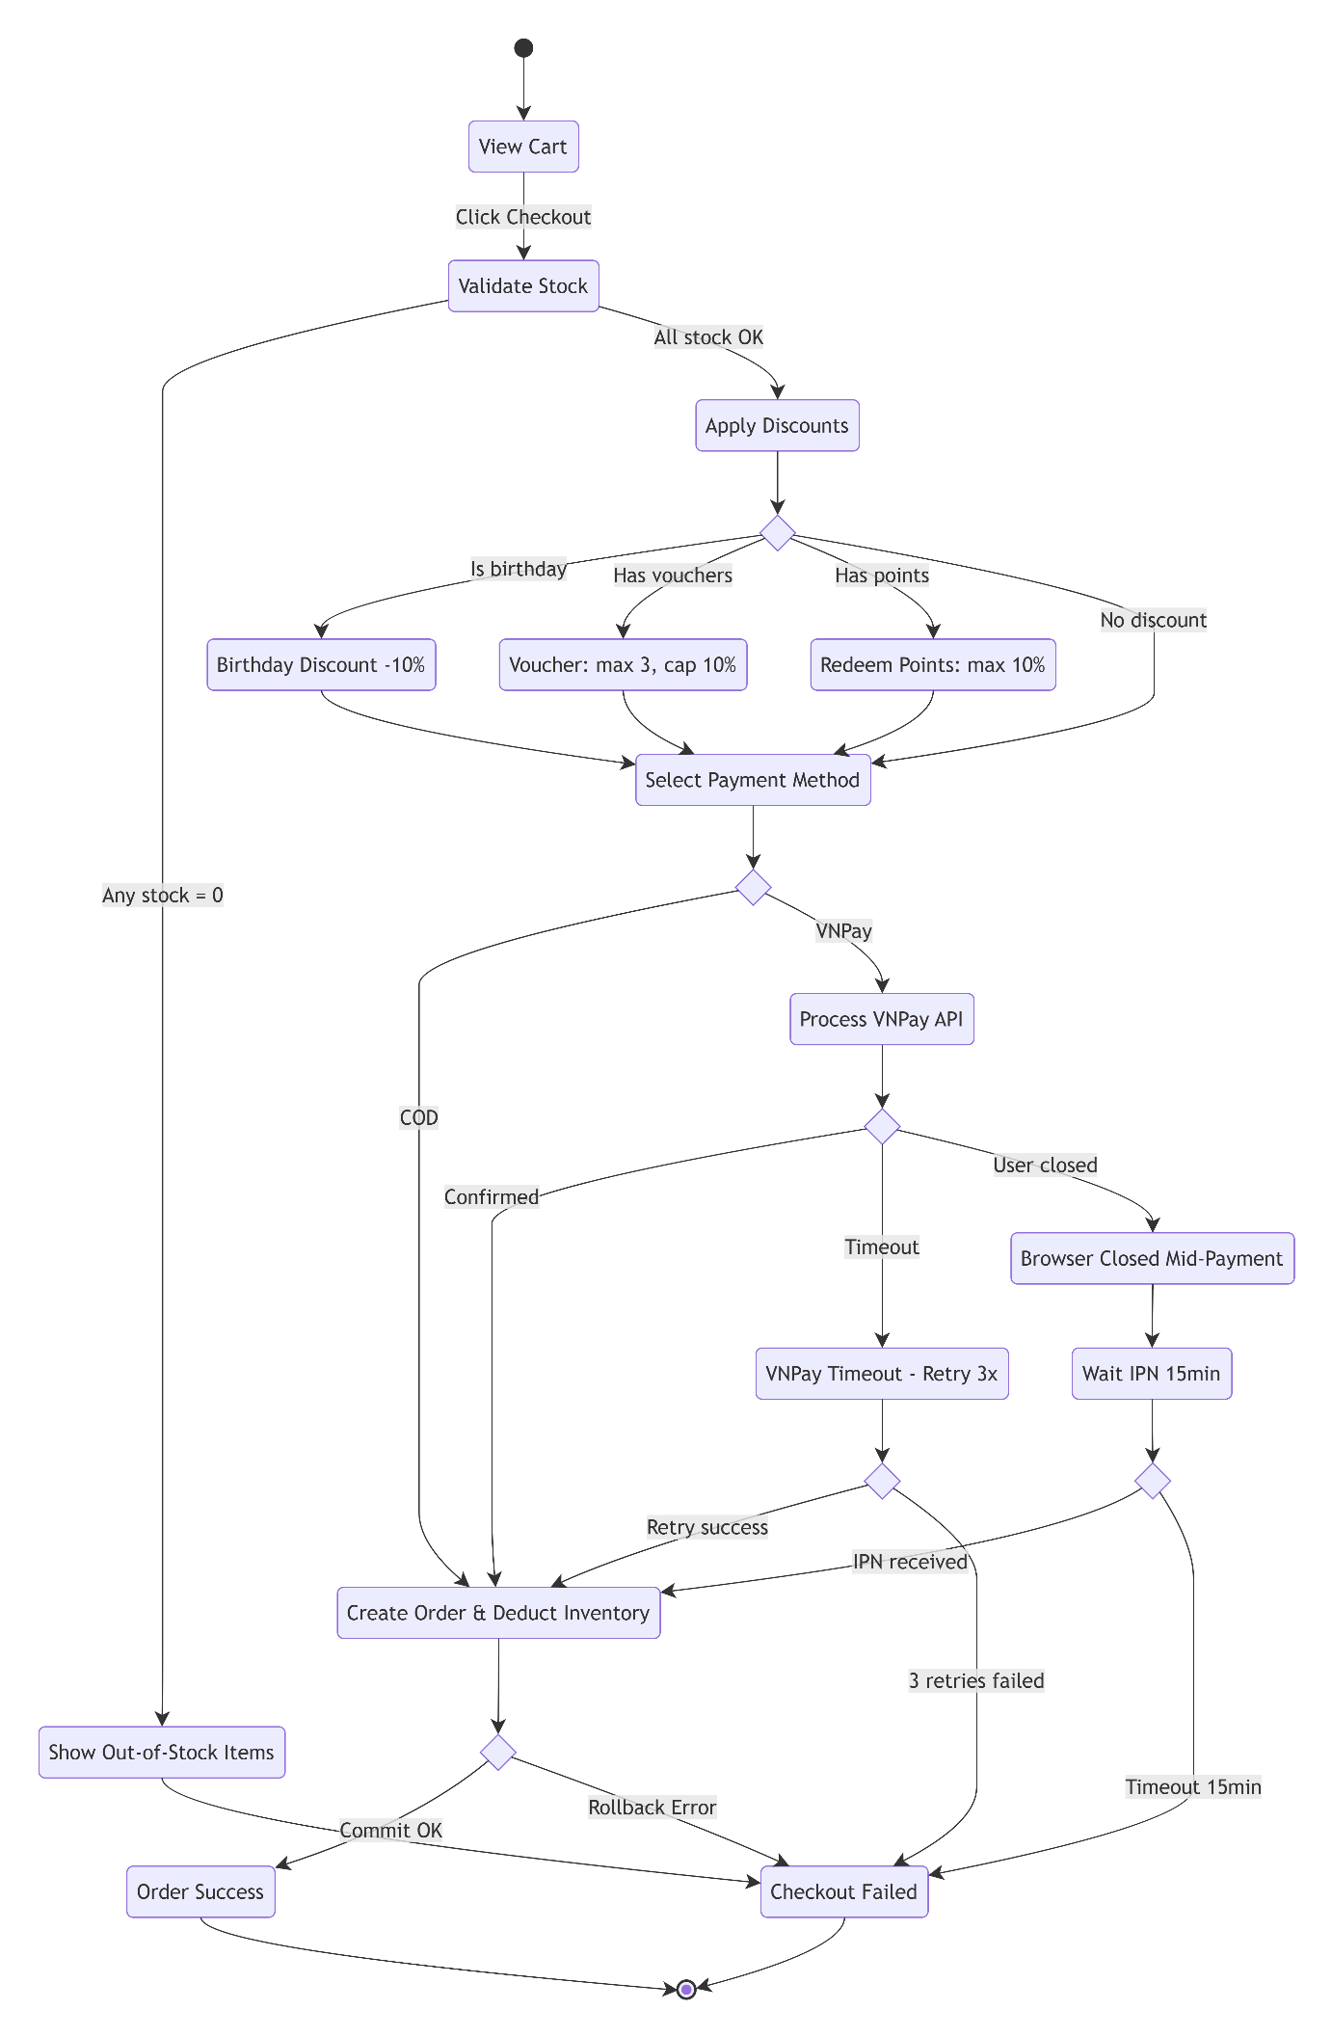
Figure 12. Checkout Flow (Activity Diagram)

4. State-Transition Diagrams (Lifecycles)
State lifecycle models of core entities in the system.

4.1 Order Lifecycle
The lifecycle of an order, from successful placement to delivery or cancellation/return (BR-12).
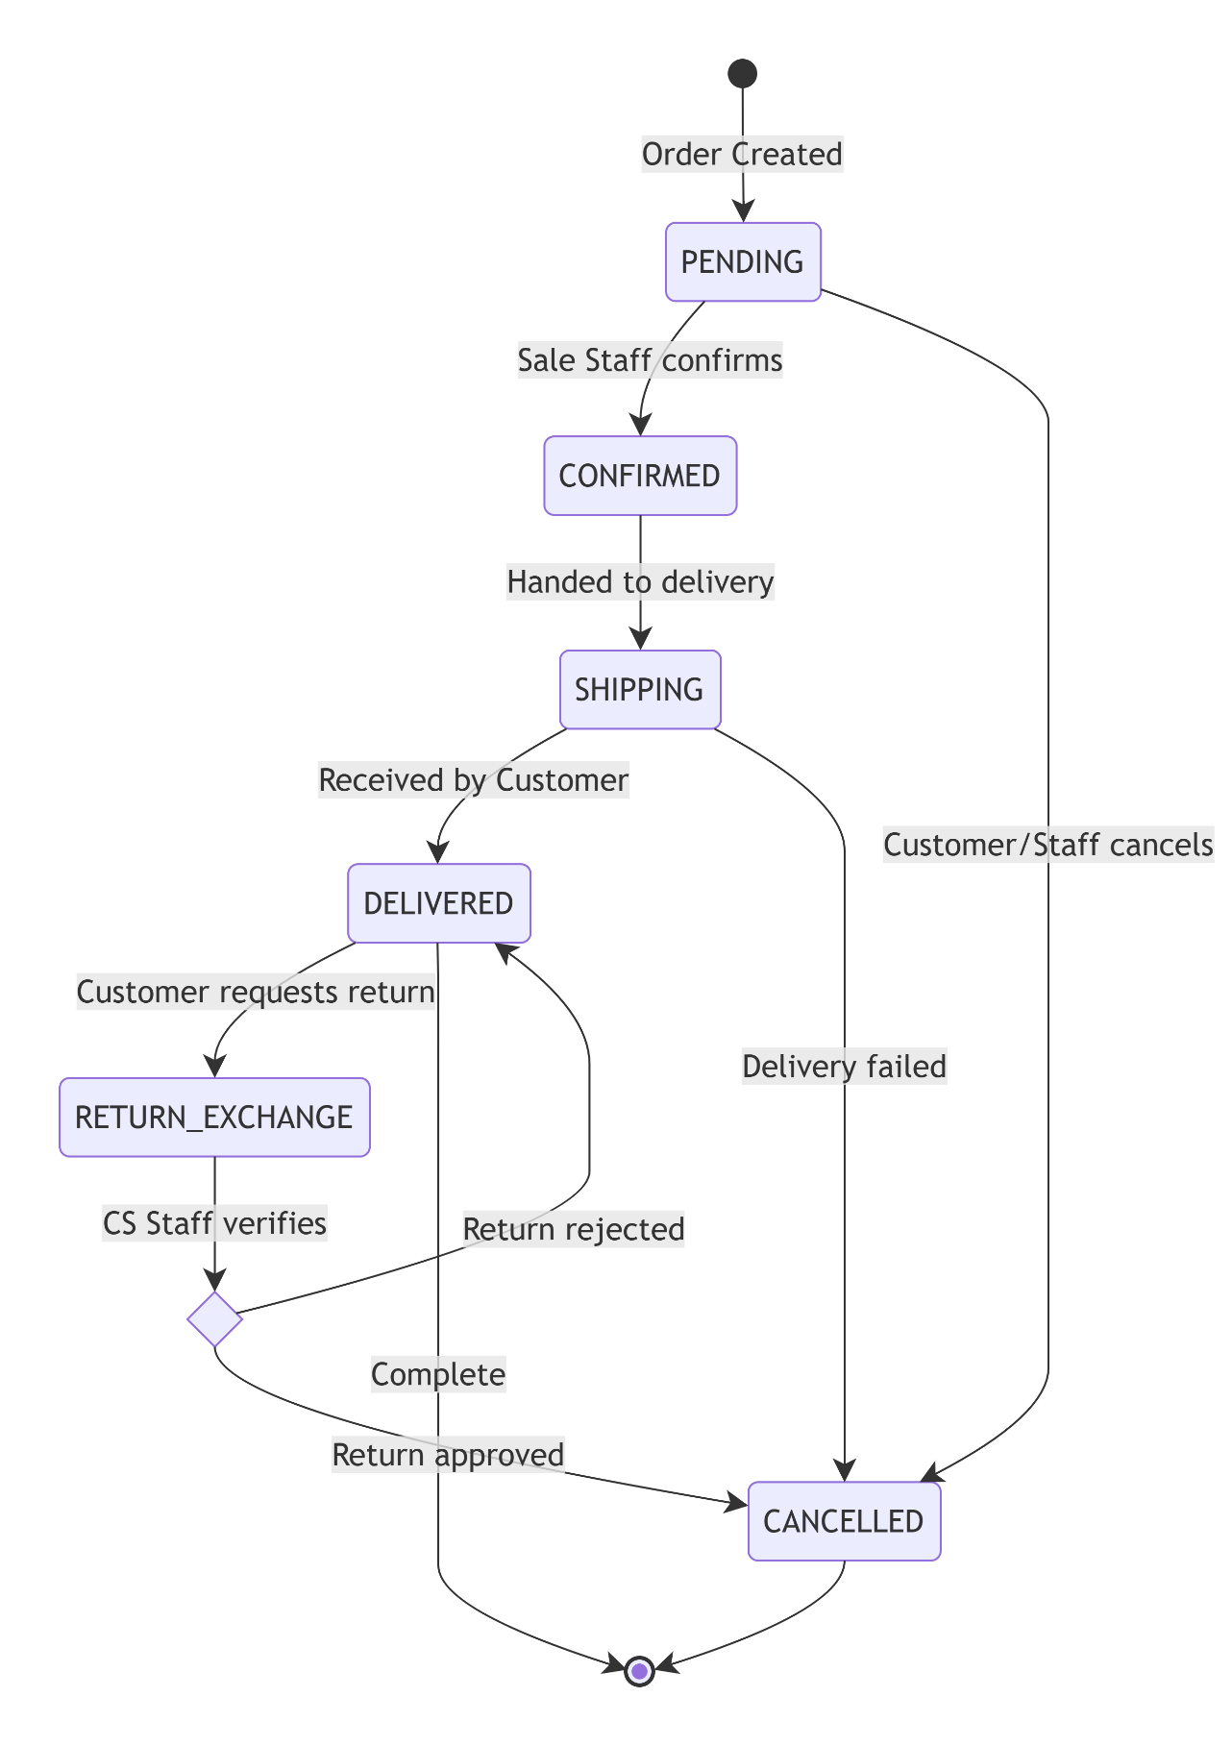
Figure 13. State-Transition Diagrams (Order Lifecycle)

4.2 Support Ticket Lifecycle
The lifecycle of a Support Ticket.
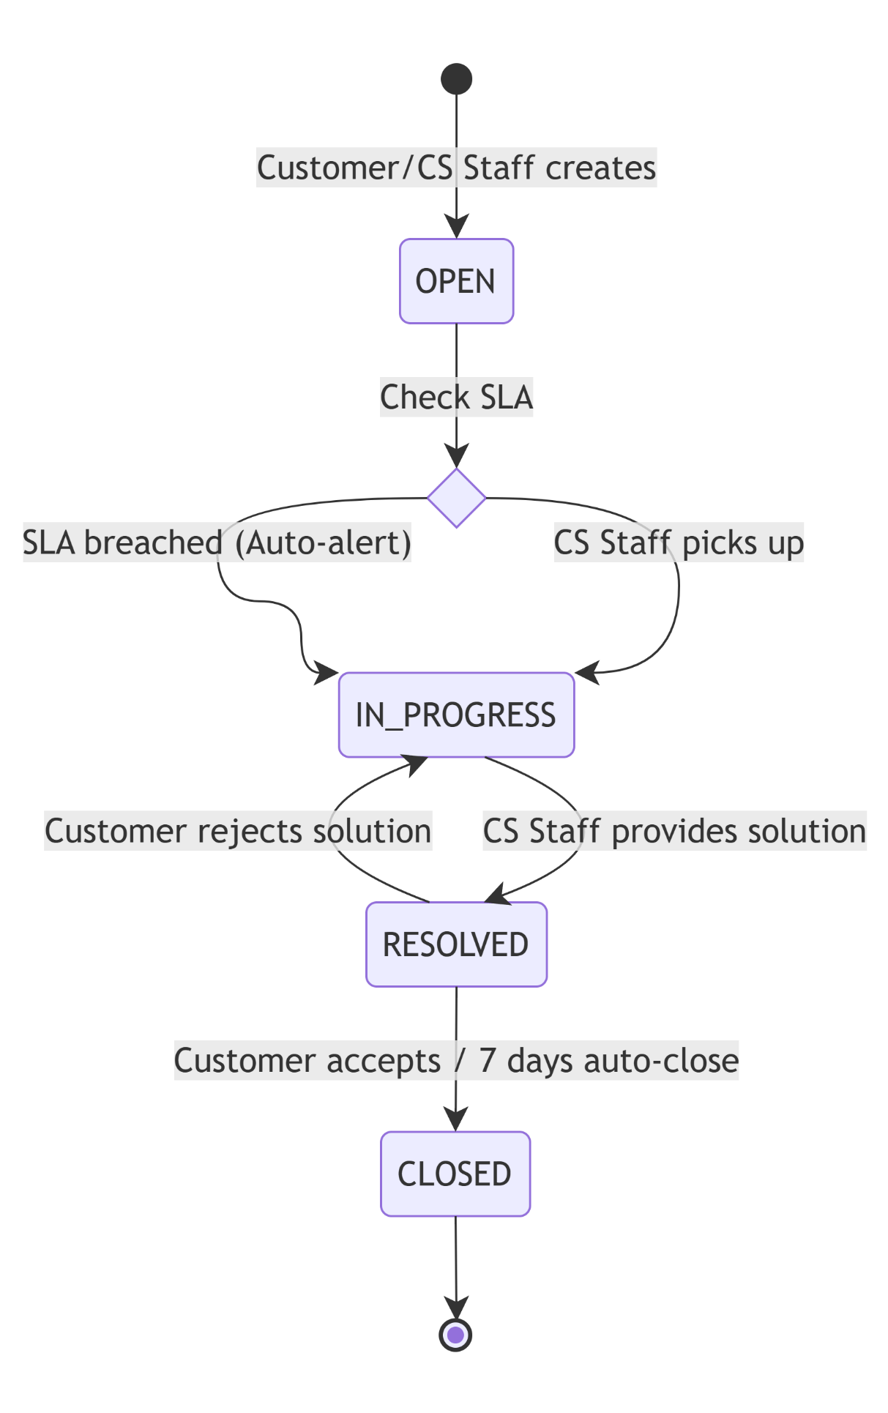
Figure 14. State-Transition Diagrams (Support Ticket Lifecycle)
(Note: The above diagram corresponds to the 2-working-day SLA processing procedure of FR-SUP-03)

